

**Group Members**

**Bushra Naz 2022140**

**Mahnoor Omer 2022912**

**Isra Chaudry 2023264**

**Subject: CY201**

**Faculty: CYS**

**Instructor: Sir Abdullah Bin Zarshaid**

**CY201 Project**

**MODULE 20**

**CRYPTOGRAPHY**

**LAB TASKS**

**LAB 01**

**Encrypt the Information Using Various Cryptography Tools**

**Task 01:**

**Calculate One-way Hashes Using HashCalc**

* Install a HashCalc from browser in Virtual Machine

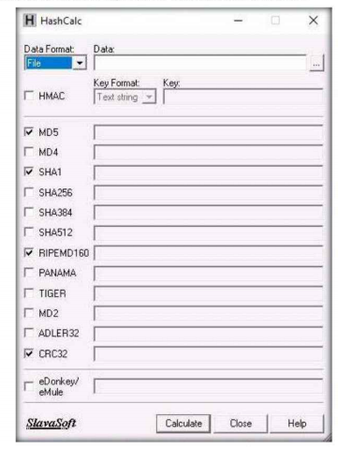

* Create a Text file on the Desktop naming MyFile.txt

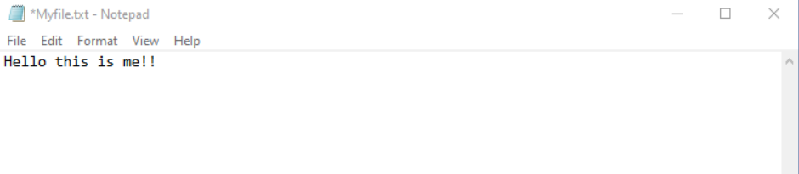

* Select the Text File from the Desktop in HashCalc

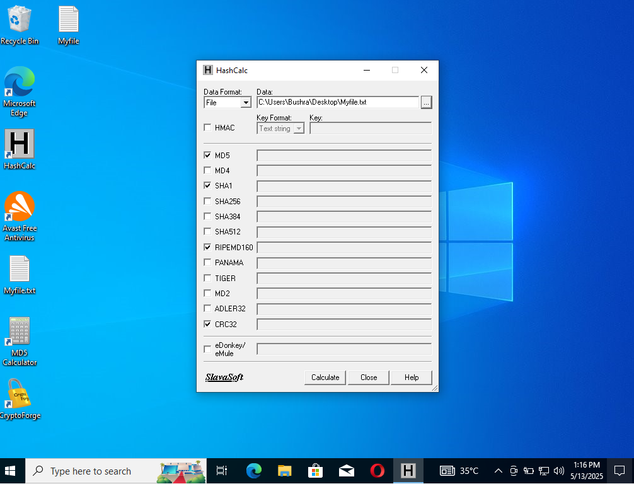

* Calculate the Hash Value of the Following Text file

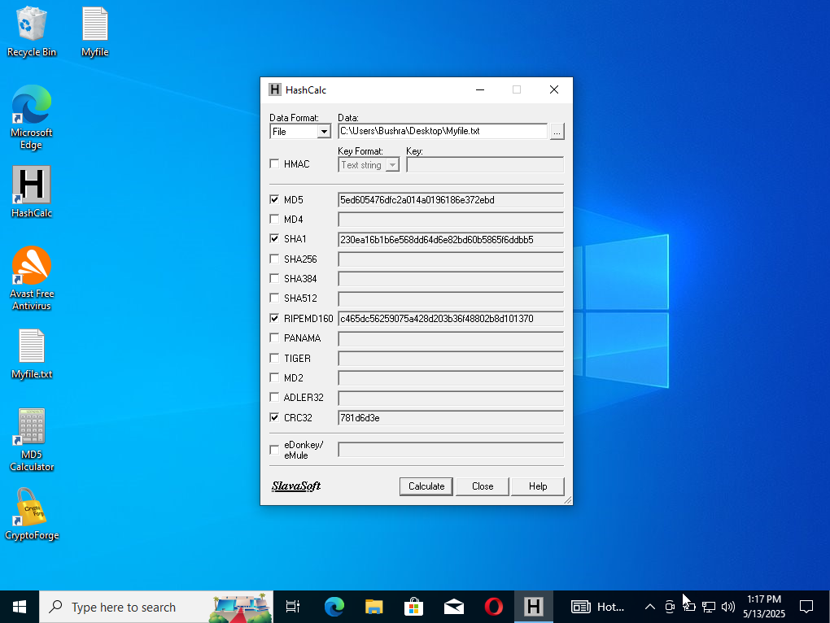

* Again, create a text file on the desktop in order to compare the hash values of both files

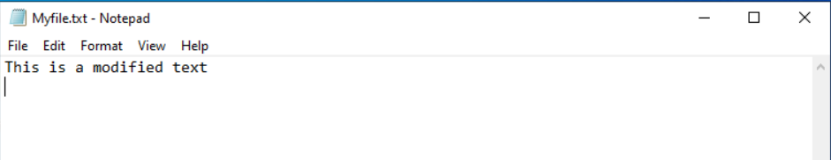

Insert this new file in HashCalc and calculate the values

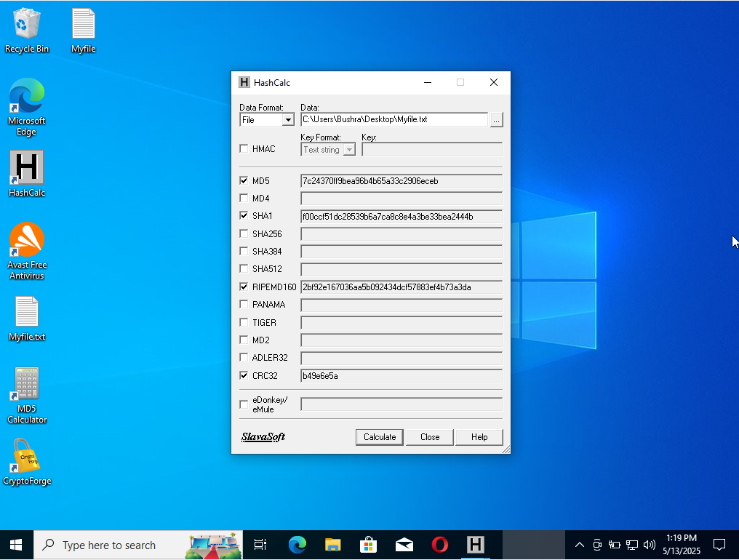

* Now Compare Both Hash Values are different

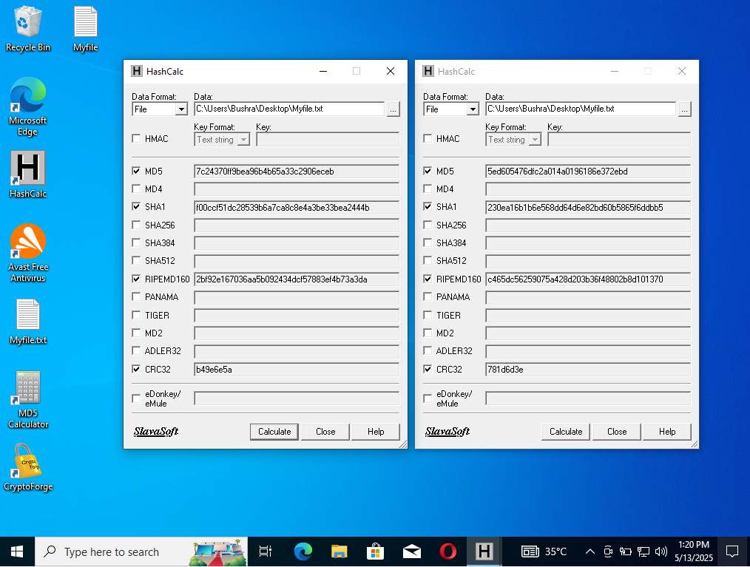

**Task 02:**

**Calculate MD5 Hashes using MD5 Calculator**

* Install the MD5 calculator on PC

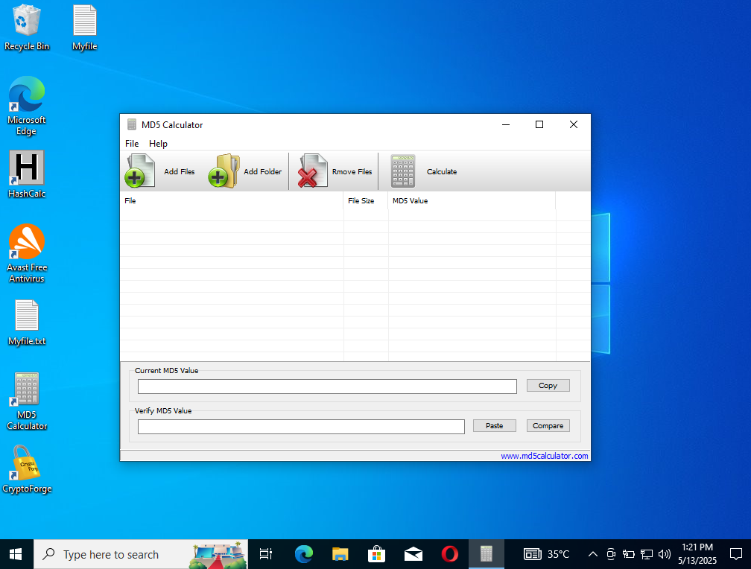

* Add file to the MD5 Calculator and calculate the value

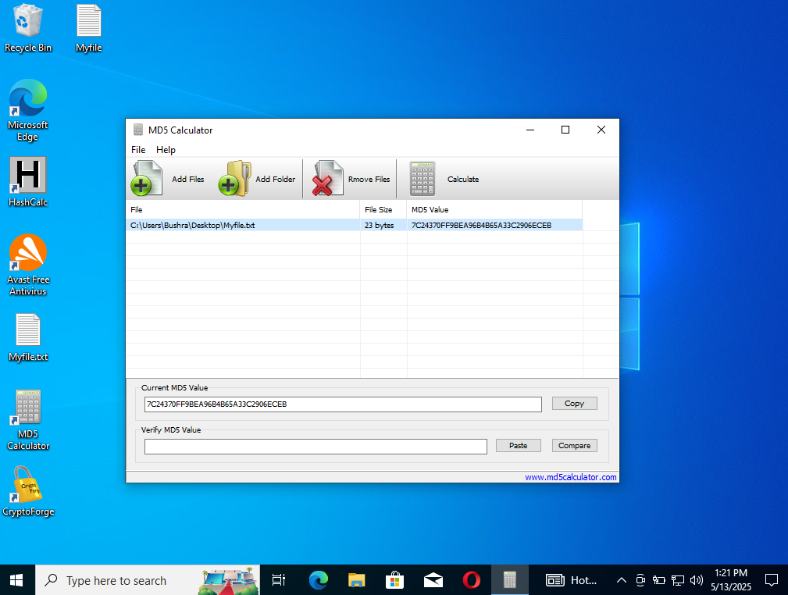

* Now click on the **copy** beside the MD5 value, to copy the hash value from **Current MD5 Value** field and click on **Remove Files** to clear the MD5 values
* Now add the other file to the MD5 Calculator for comparison

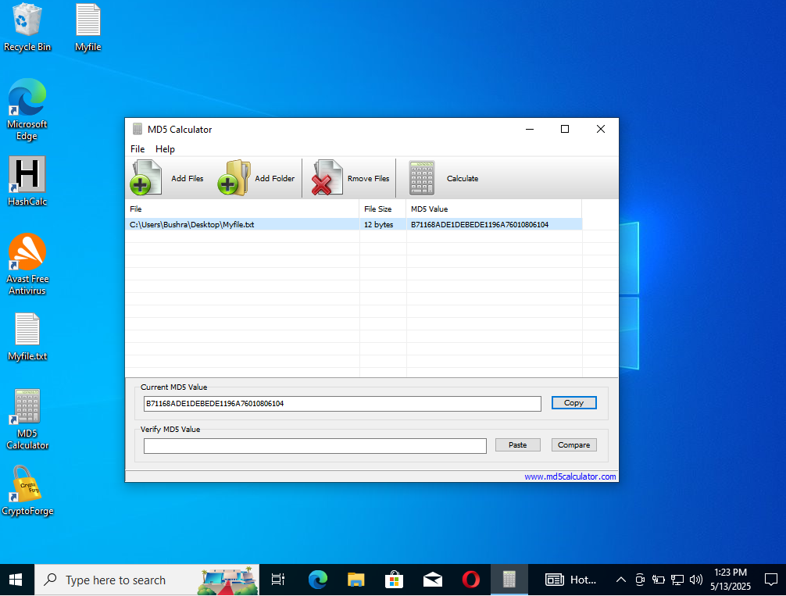

* By comparing the two MD5 Values,

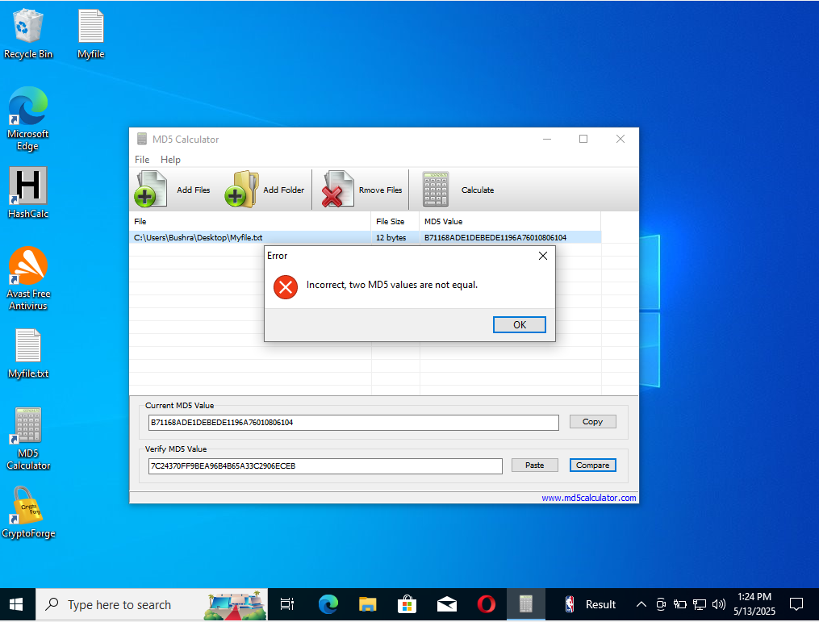

**Task 03:**

**Calculate MD5 Hashes Using HashMyFiles**

* Download the HashMyFiles on the virtual PC

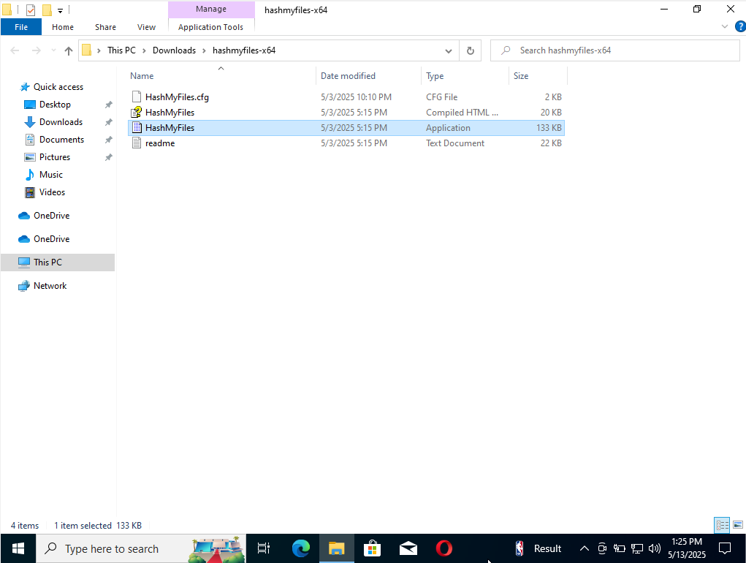

* In the **HashMyFiles** window, click File from the menu bar. From the Drop-down menu, click the **AddFolder** option.

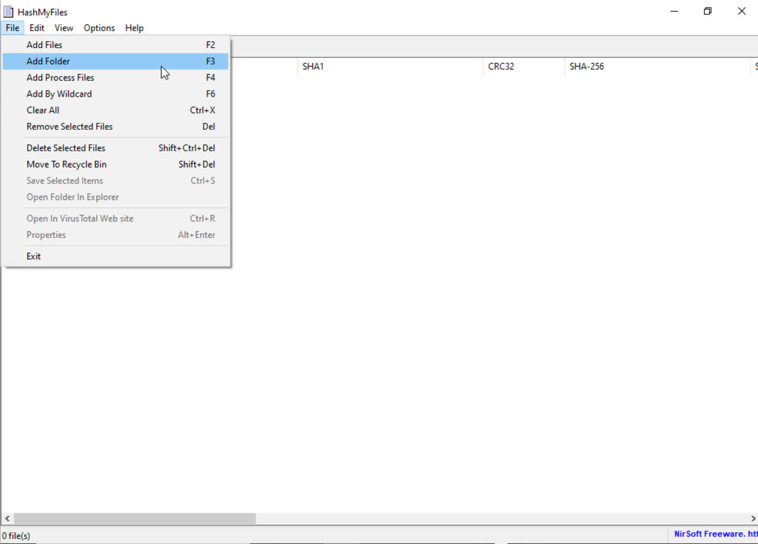

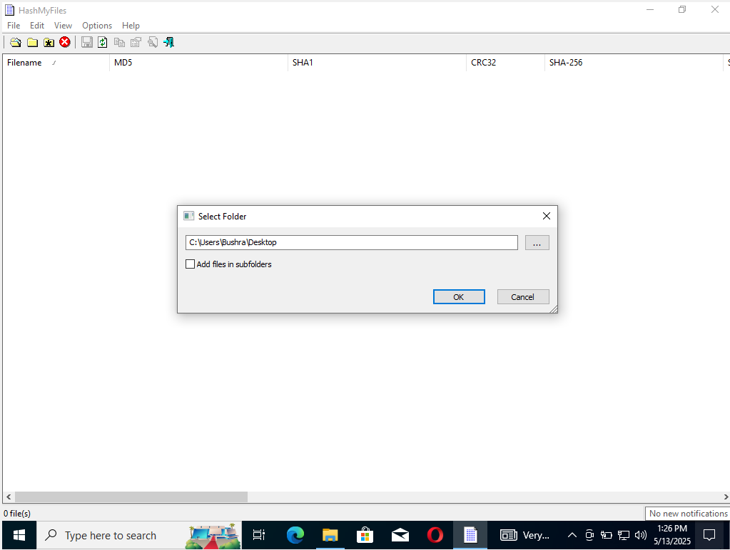

* A list of files contained in the folder appears, along with their various hash values such as MD5, SHA1 etc.

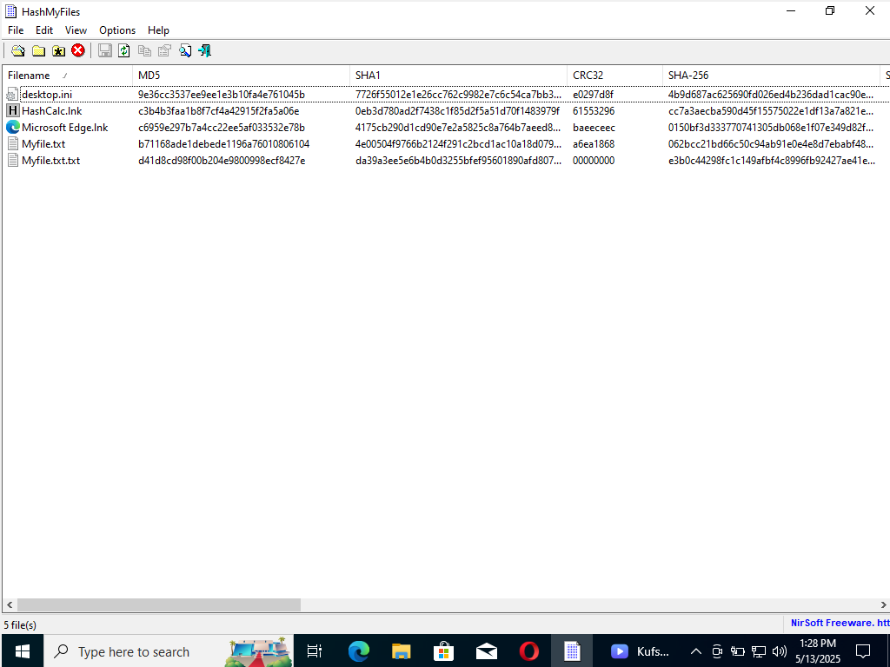

* After selecting the Hash type, from the list of hash functions, unselect CRC32, SHA-256, SHA-512 and SHA-384 hash types one by one and after refreshing it will show the selected types

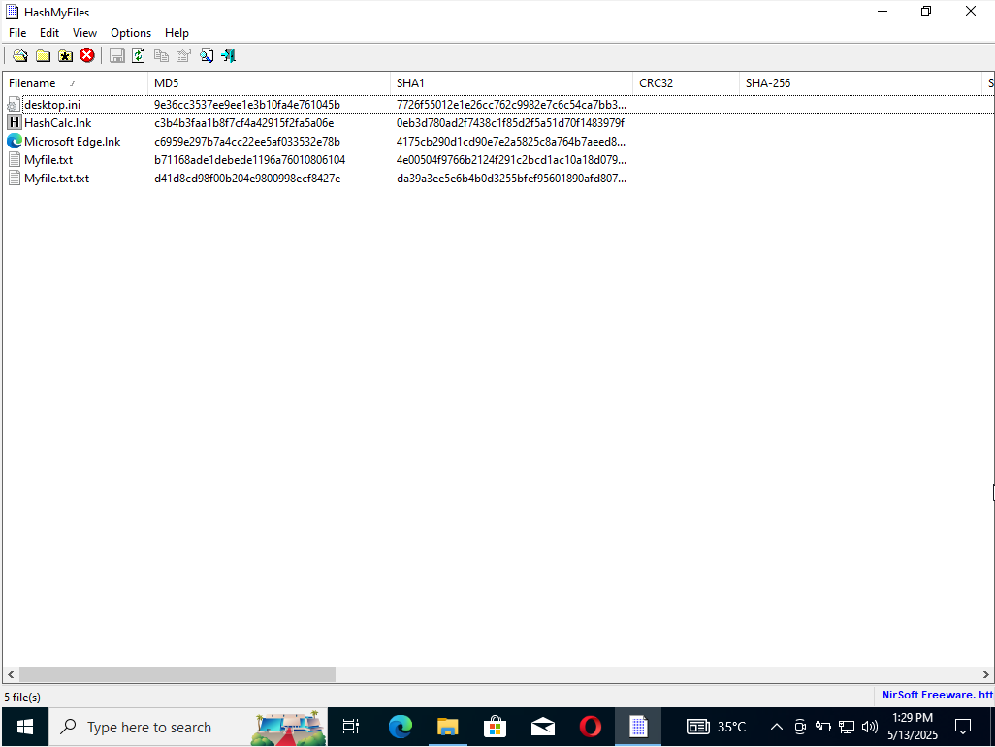

**Task 04:**

**Perform File and Text Message Encryption using CryptoForge**

* Install a CryptoForge on Virtual PC

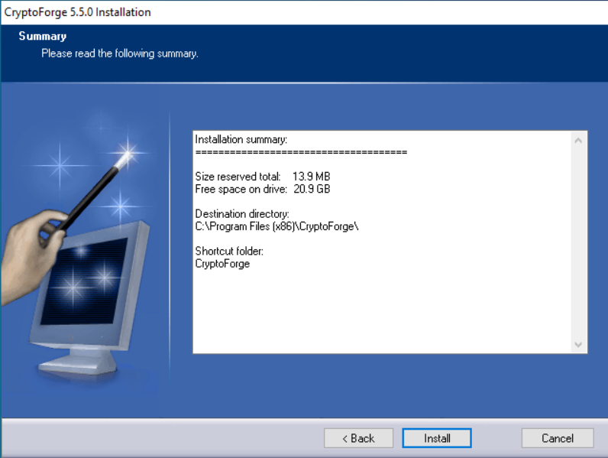

* Click the MyFile.txt file located at the desktop and click show more options and select **encrypt** from the context menu

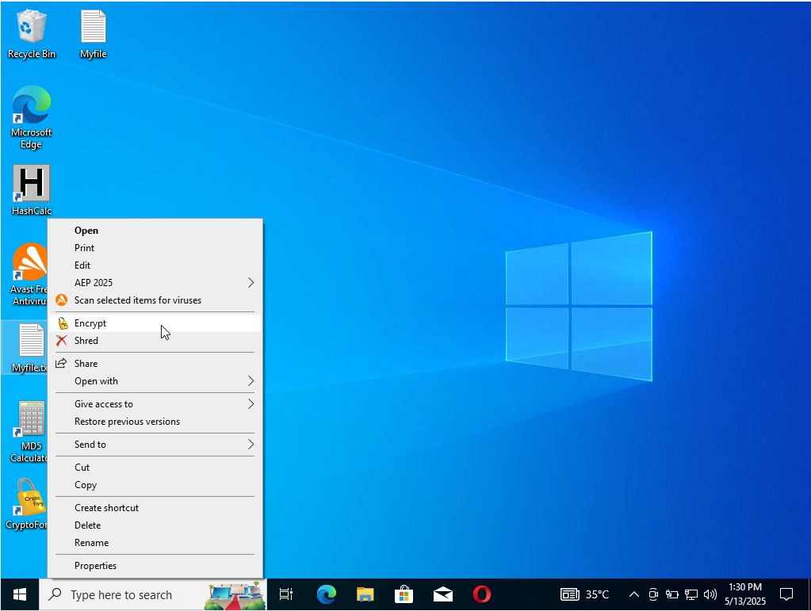

* Enter passphrase- CryptoForge files dialog-box appears, type a password in the Passphrase field, retype it in the Confirm field and then click OK. The Password used in it is qwerty@123

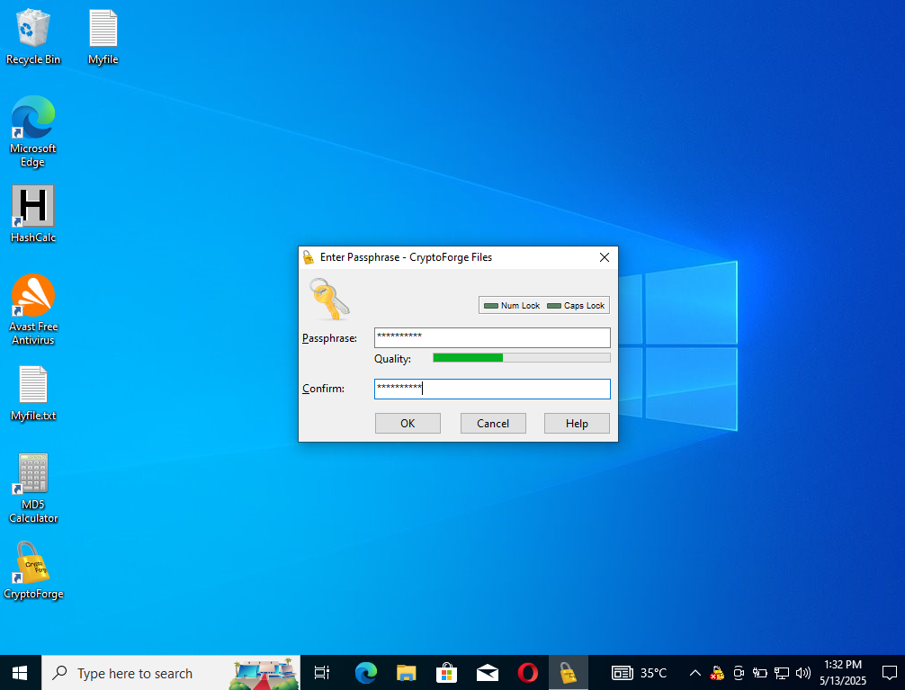

* After giving the passcode, we can observe there is an encrypted file on the same location and the previous one is deleted automatically.

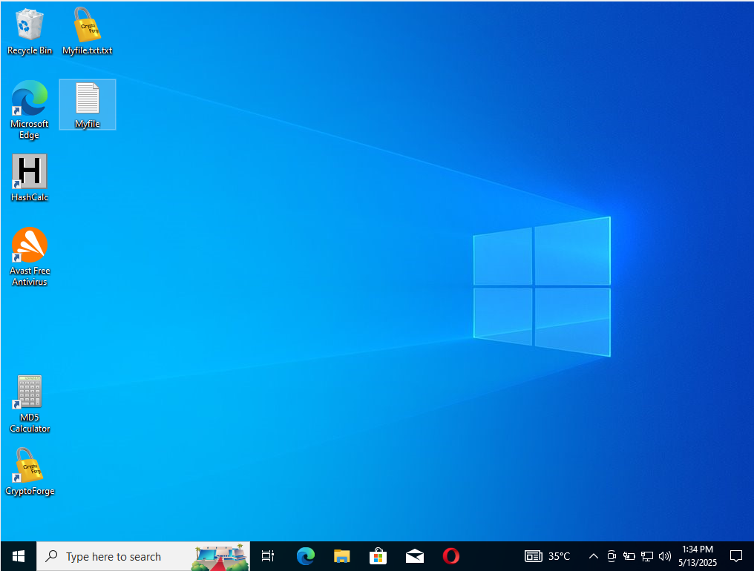

* To view the content in the File we need to decrypt the file and when click on the decrypt option we need to enter the passcode again

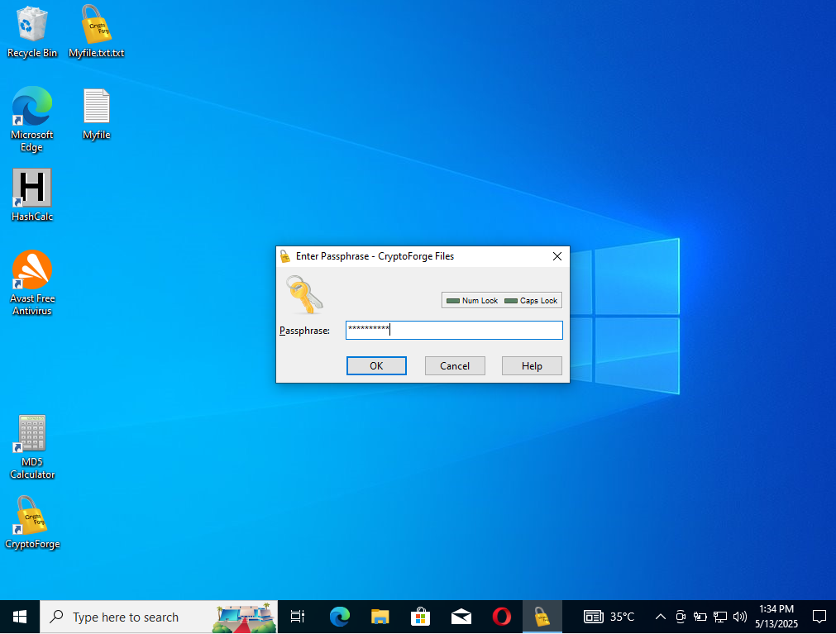

* Once decrypt the file becomes into its Original form and we can read the text

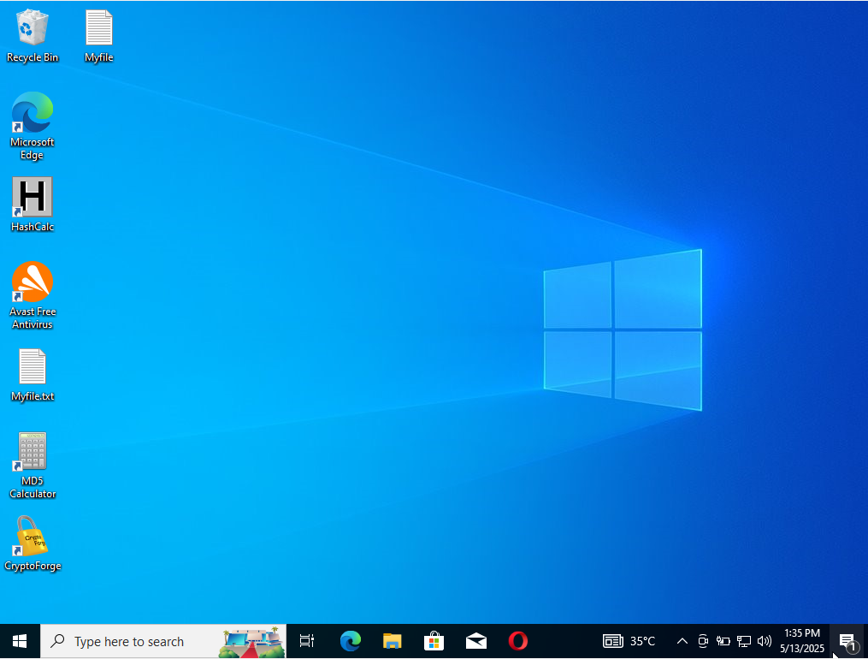

* We can read the file now

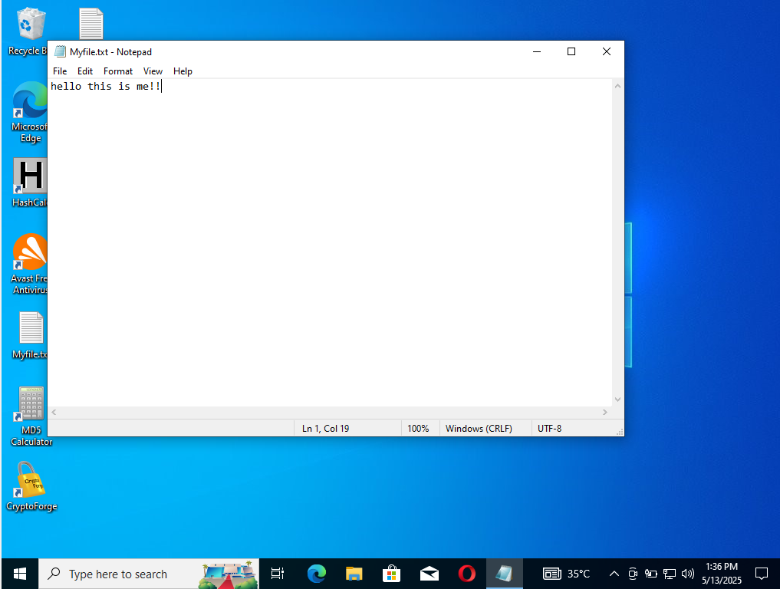

**Task 05:**

**Perform the File Encryption Using Advanced Encryption Package**

* Install the Advanced Encryption Package on Virtual PC
* After Installing AEP, activate it by clicking on the activation option

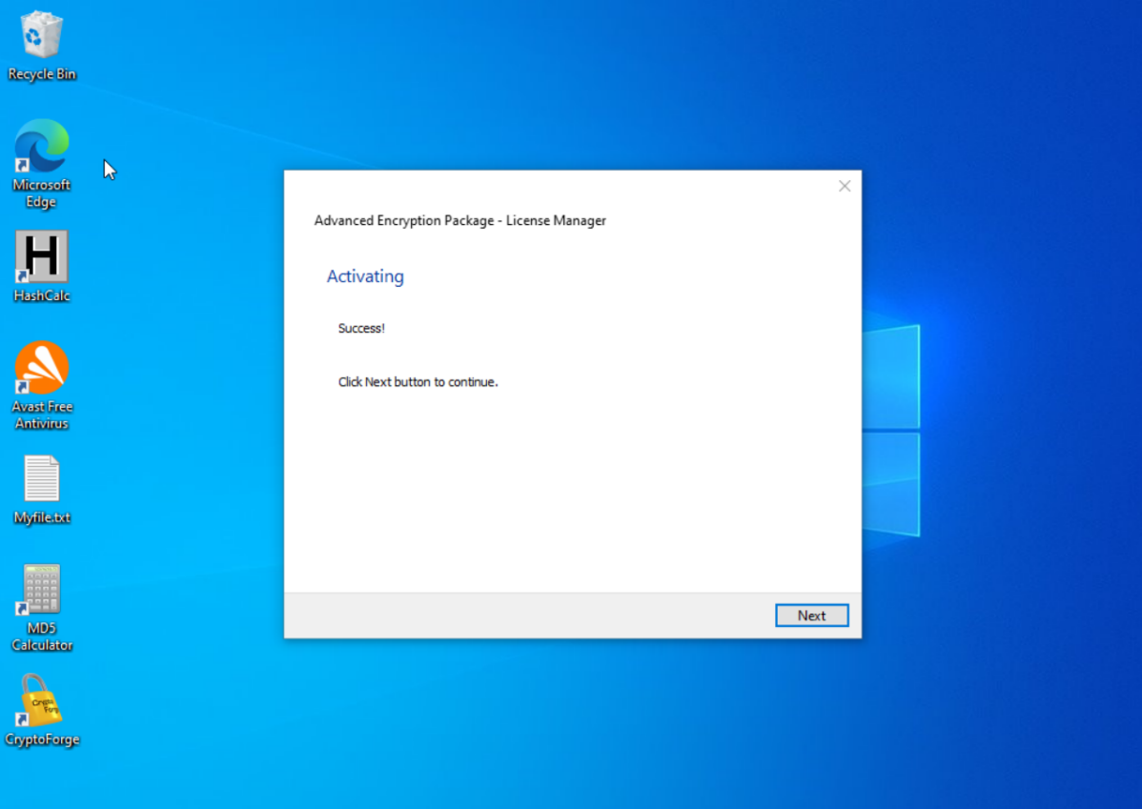

* Leave all options set to default in the License Information step and click on finish

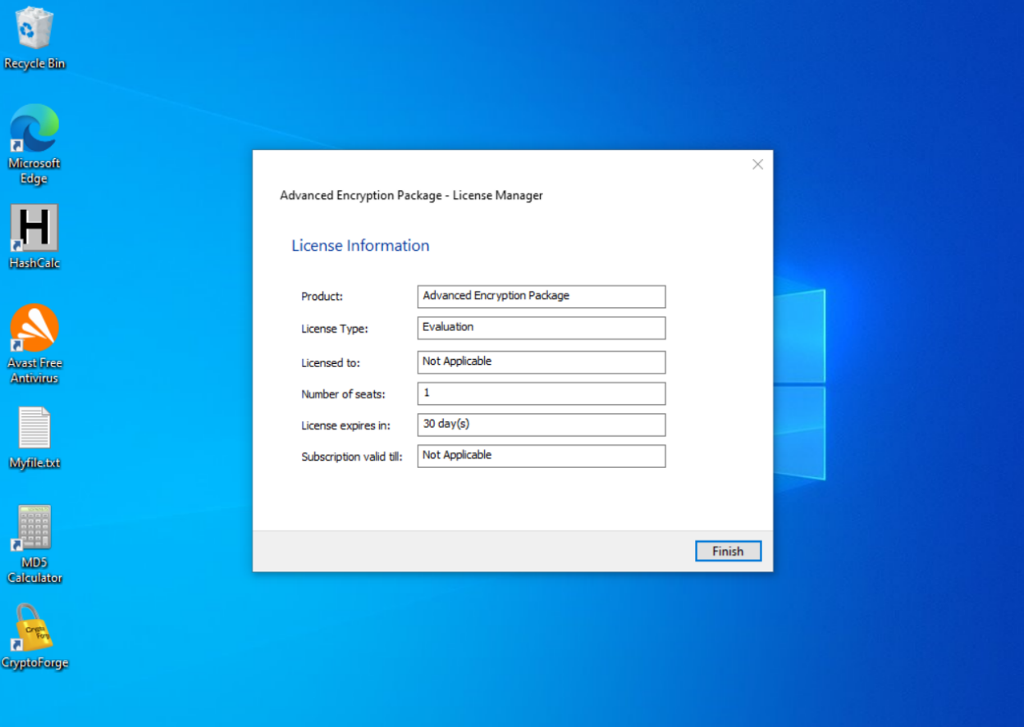

* The Advanced Encryption Package windows appear

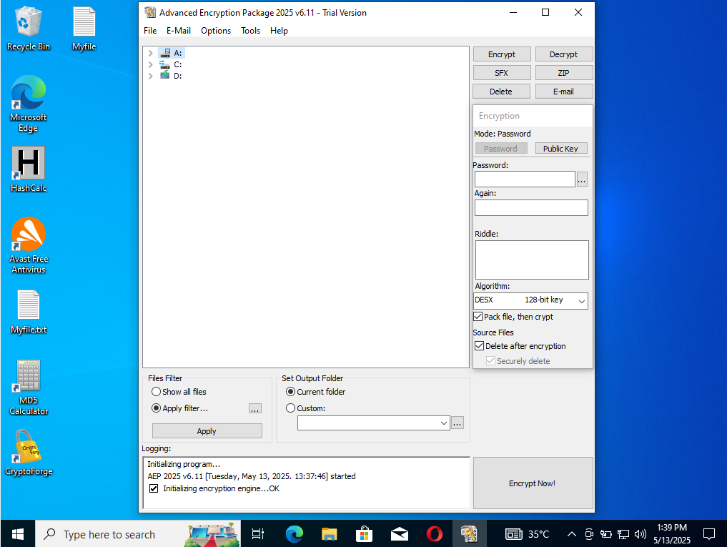

* In the Advanced Encryption Package window, expand the C: drive. Select the vboxpostinstall.log file located in the given location and click **Encrypt** in the toolbar

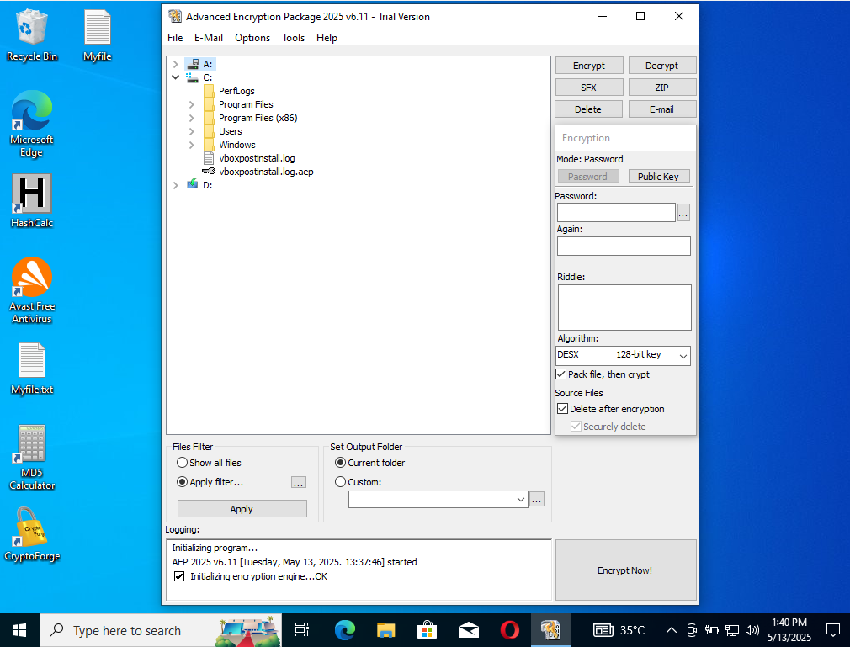

* After giving the password to the file, it is **encrypted** now

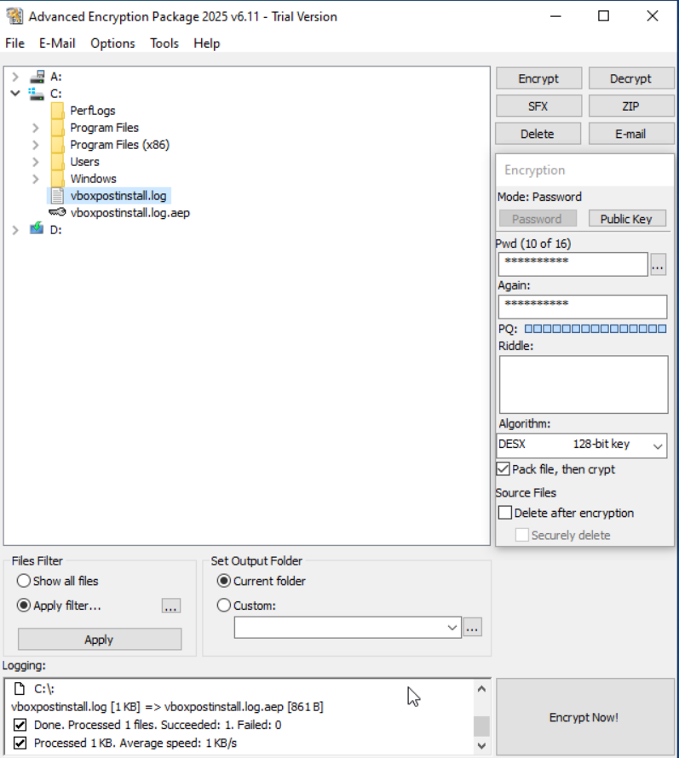

* Under the Source Files section in the right panel, click the Delete button to delete the source file then, click **Decrypt now**!

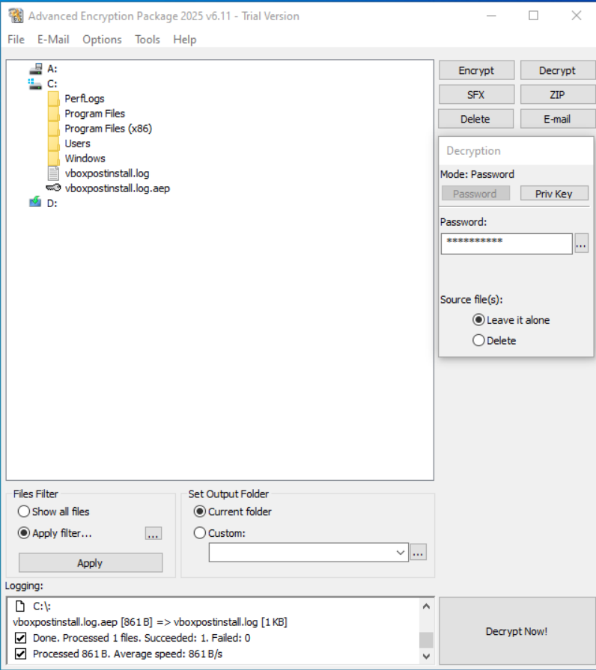

* The File already exists, pop-up show then click **YES**

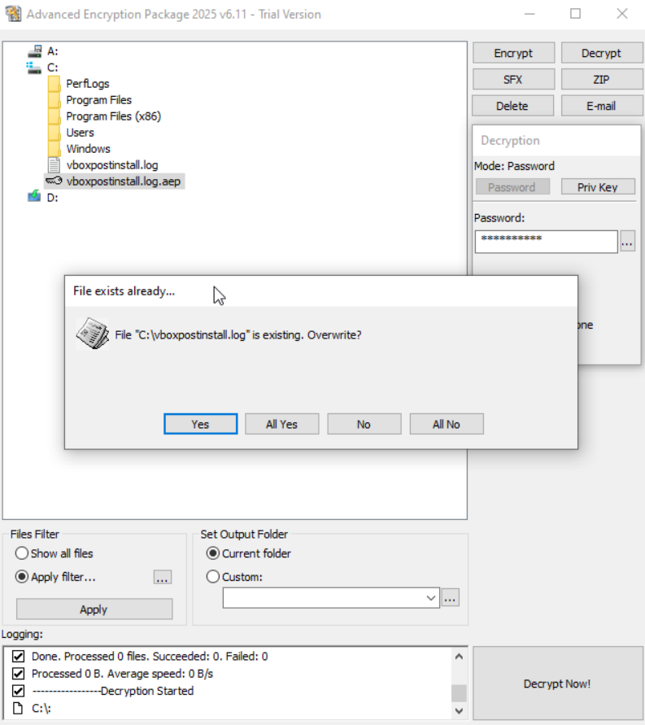

**Task 06:**

**Encrypt and Decrypt data using BCTextEncoder**

* Install the BCTextEncoder on virtual PC

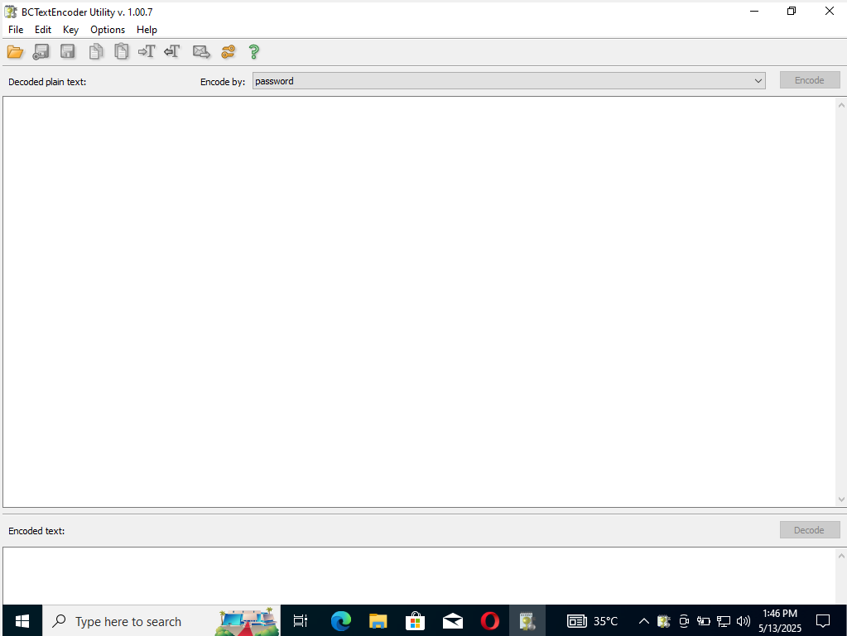

* To encrypt the text, insert the text in the clipboard. Ensure that the **password** option is selected in the Encode by field and click **Encode**

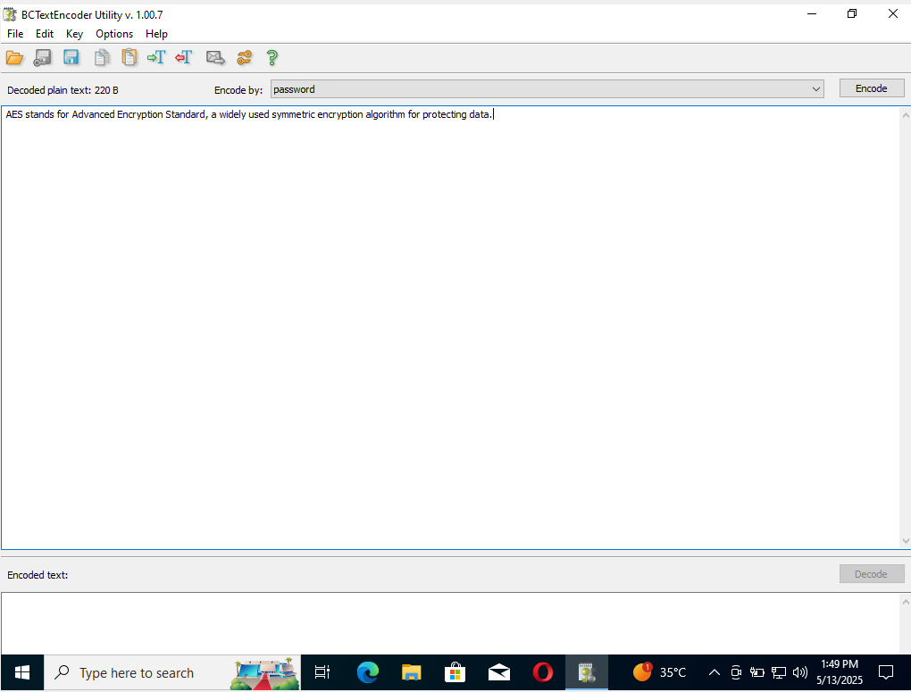

* The **Enter Password** pop-up appears, enter the password into the **Password** field and retype it in the confirm field, then click **OK**.

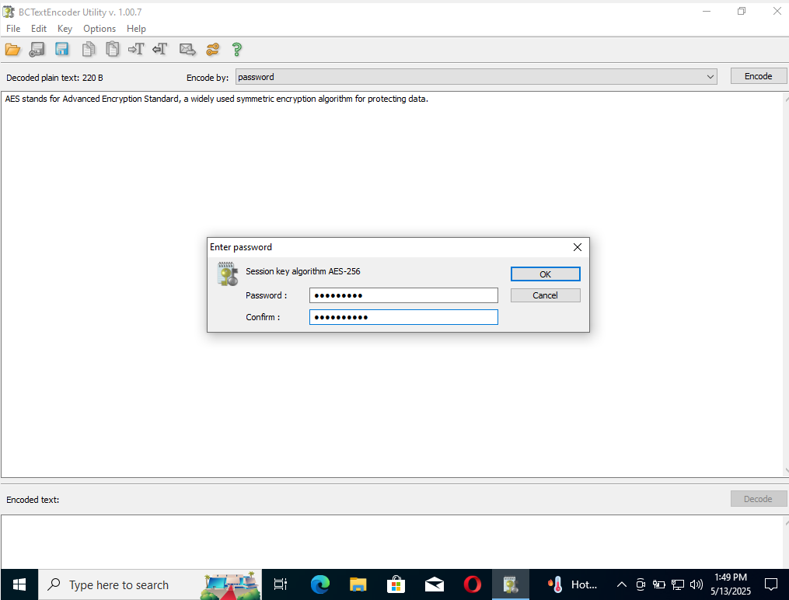

* BCTextEncoder encodes the text and displays it in under the Encoded text section.

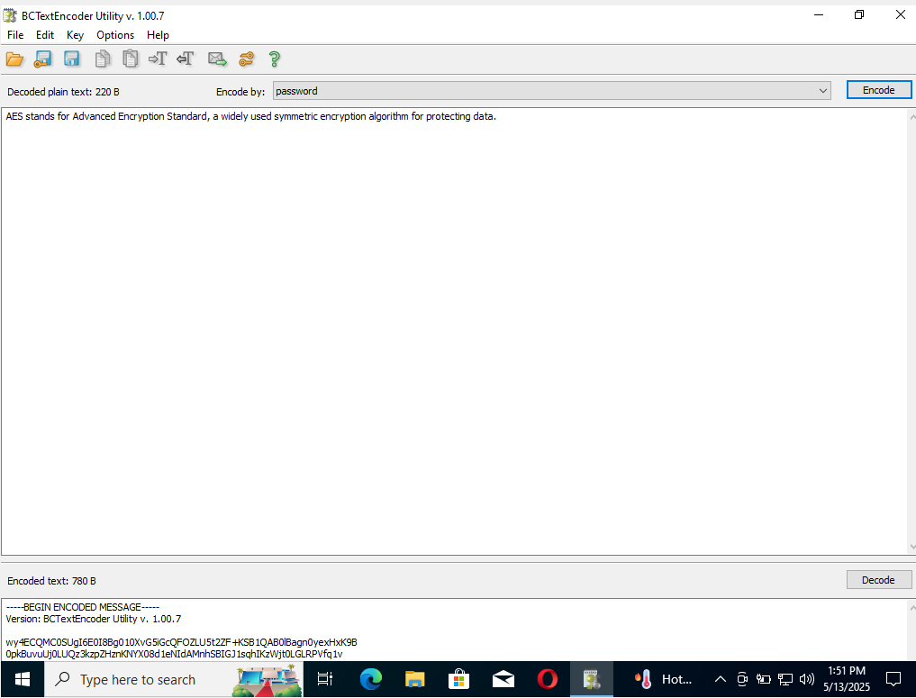

* To decrypt the data, first, we need to clean the **Decoded plain text** in the clipboard, and then click the **Decode** button.
* The **Enter Password for encoding text** dialog-box appears, insert the **Password** into the password field and click **OK**.

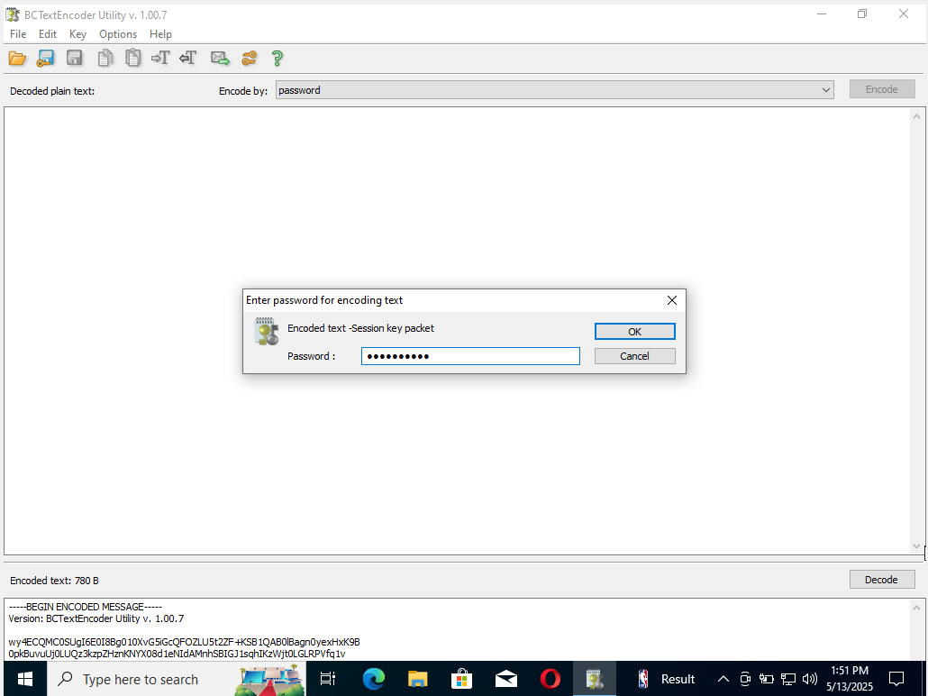

* The decoded plain text appears under the Decoded plain text section

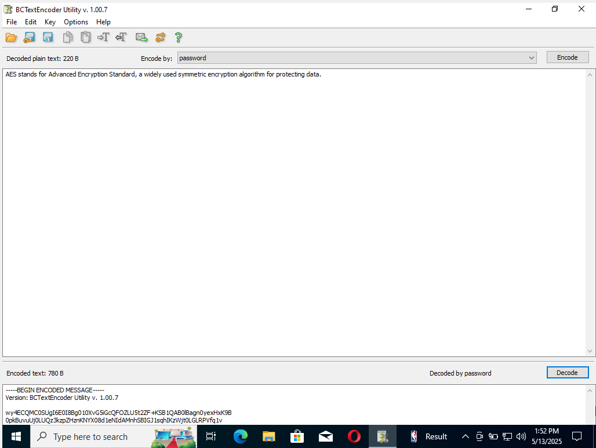

**LAB 02**

**Creating a Self-Signed Certificate**

**Task 01**

**Create and Use Self-Signed Certificate**

* Turn on the Window Server 2022 virtual machine. Click Ctrl+Alt+Del to activate the machine. By default, Administrator profile is selected, type password and press enter to login.
* Before starting the task, we will need to check the local sites whether they include the self-signed certificate.
* Launch the web browser (Google chrome) place the cursor in the address bar and type [https://www.goodshopping.com](https://www.goodshopping.com/), and press enter.
* As we are using an https channel to browse the website, it displays a page stating that **This site can’t be reached.**
* As site doesn’t have a self-signed certificate, it displays a connection refused message, close the web browser**.**

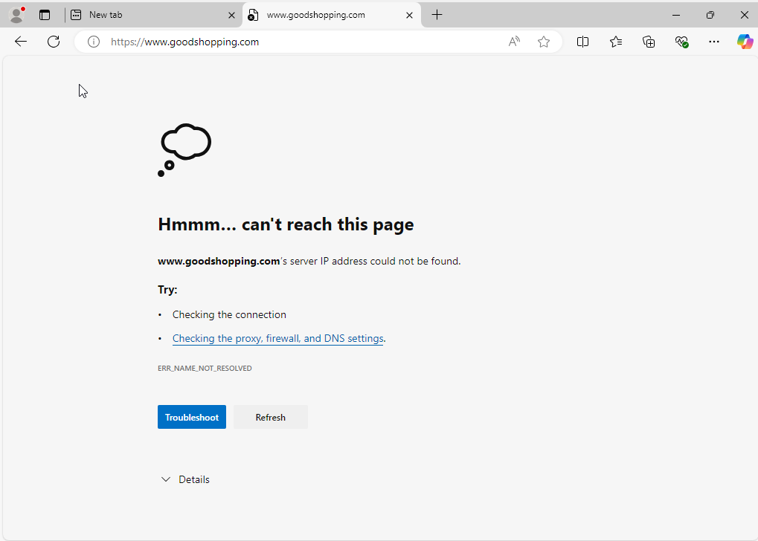

* Click the **Type here to search** icon present in the bottom-left of Desktop and type iis. Select **Internet Information Services (IIS) Manager** from the result.

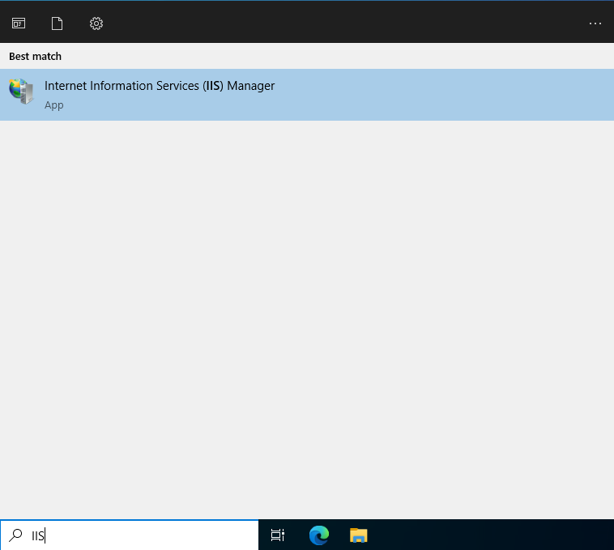

* The **Internet Information Services (IIS) Manager** window appears, click machine name **(Server2022 (Server2022/Administrator))** under the connections section from the left-hand pane
* In **Server 2022** Home, double-click **Server Certificates** in the IIS section.

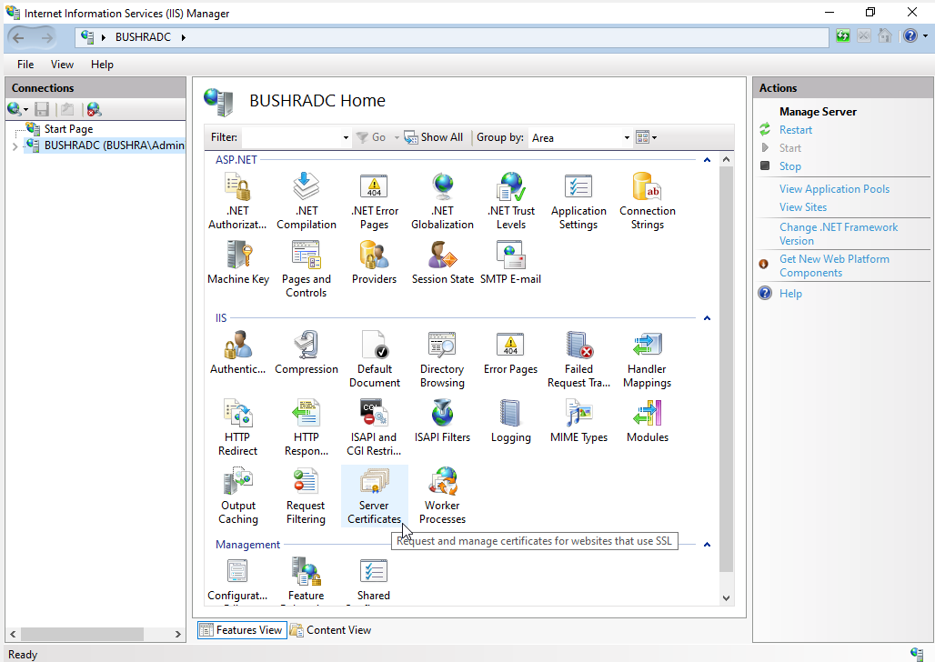

* The Server Certificates wizard appears, click **Self-Signed Certificates** from the right-pane in the **Actions** section

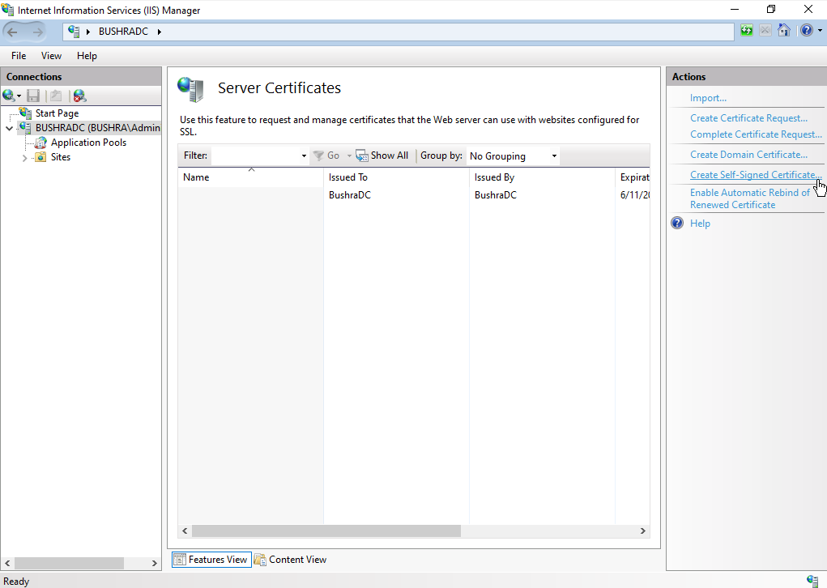

* The **Create Self-Signed Certificate** window appears type **GoodShopping** in the Specify a Friendly name for the certificate field. Ensure that the personal option is selected in the **Select the certificate store for the new certificate field** then, click ok.

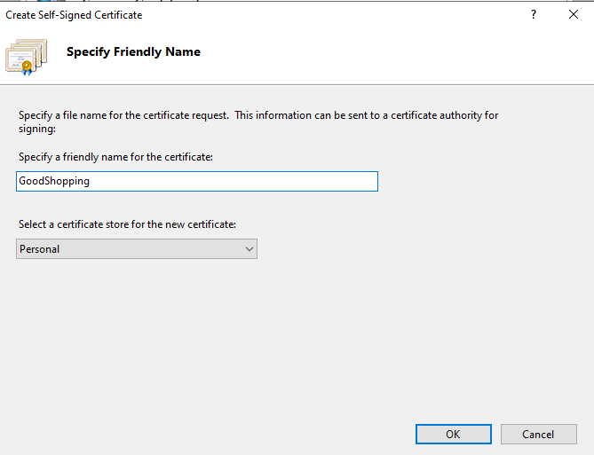

* A newly created self-signed certificate will be displayed in the Server Certificate pane.

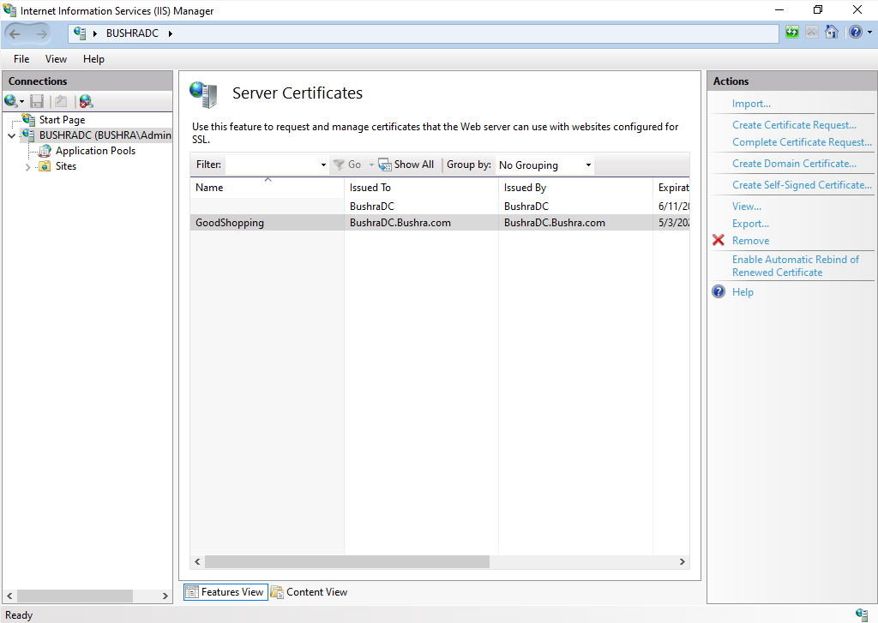

* Expand the **Sites** node from the left-hand pane and select **GoodShopping** from the available sites. Click **Bindings** from right-hand pane in the **Actions** section.

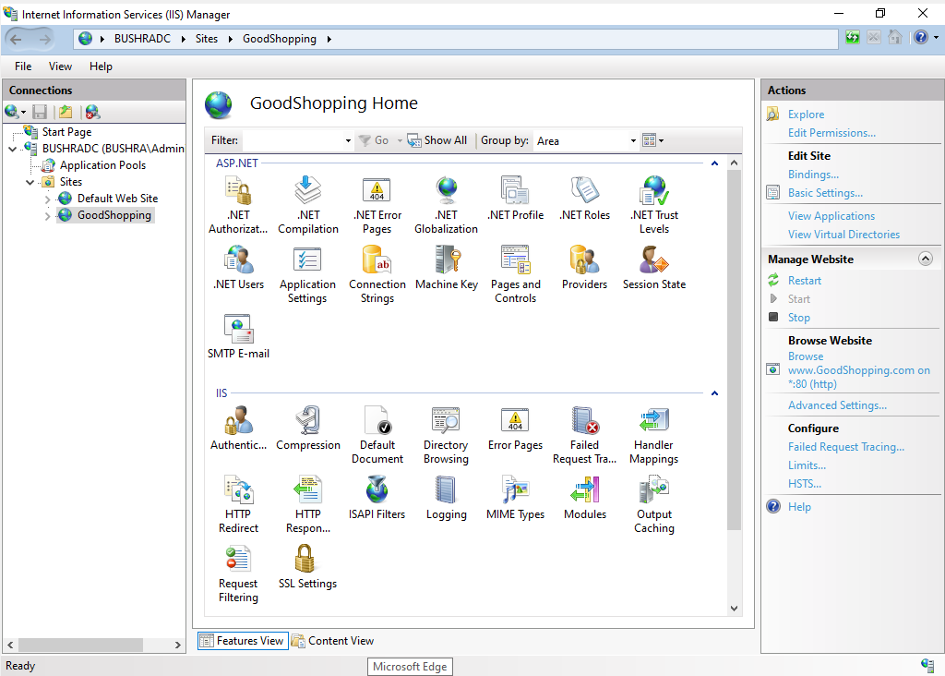

* The Site Bindings window appears, click Add

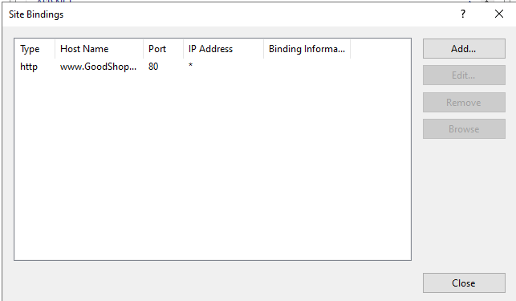

* The **Add Site Bindings** window appears, choose **https** from the **Type** field drop-down list. Once we choose the https type, the port number in the Post field automatically changes to **443**.
* Choose the IP address on which the site is hosted (10.10.1.19).
* Under the **Host name** field, type www.GoodShopping.com . Under the **SSL certificate** field, select **GoodShopping** from the drop-down list, and click **OK**.

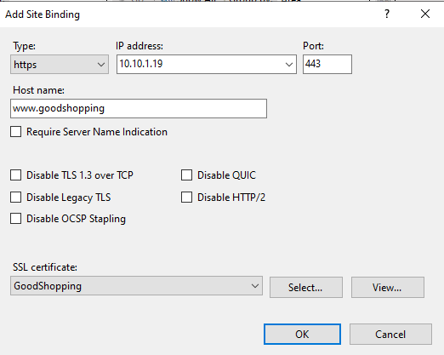

* The newly created SSL certificate is added to the **Site Bindings** window, then, click **Close**.

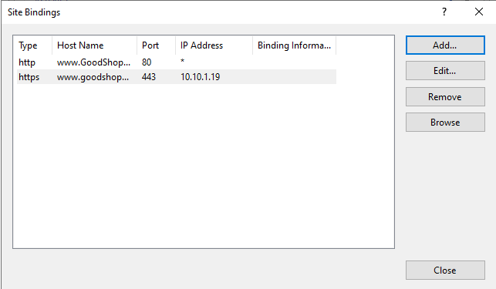

* Now, right-click the name of the site for which tou have created the self-signed certificate (GoodShopping) and click **Refresh** from the context menu.

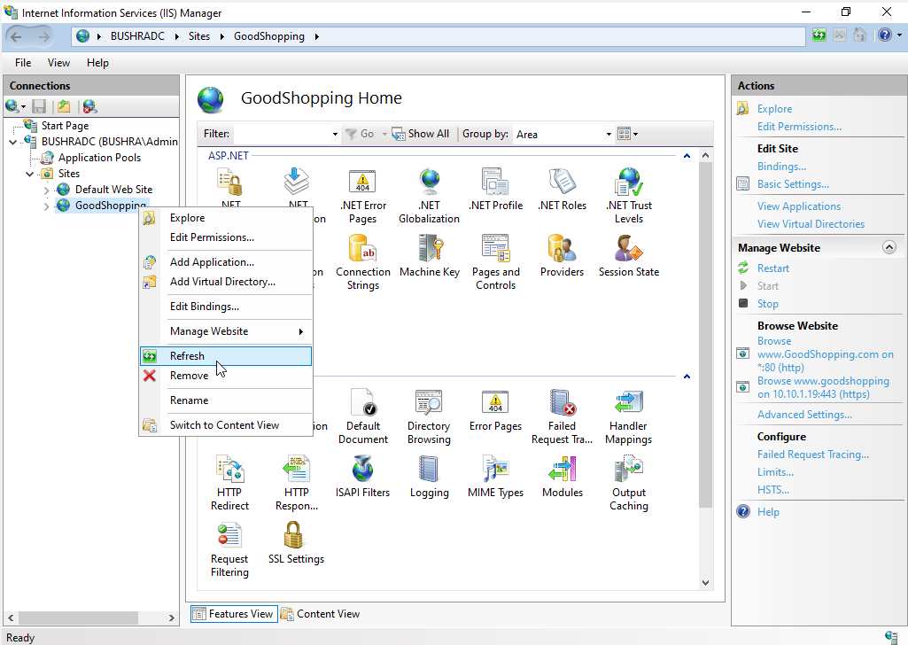

* Open the browser, place the cursor in the address bar and type [https://www.goodshopping.com](https://www.goodshopping.com/), and press Enter.

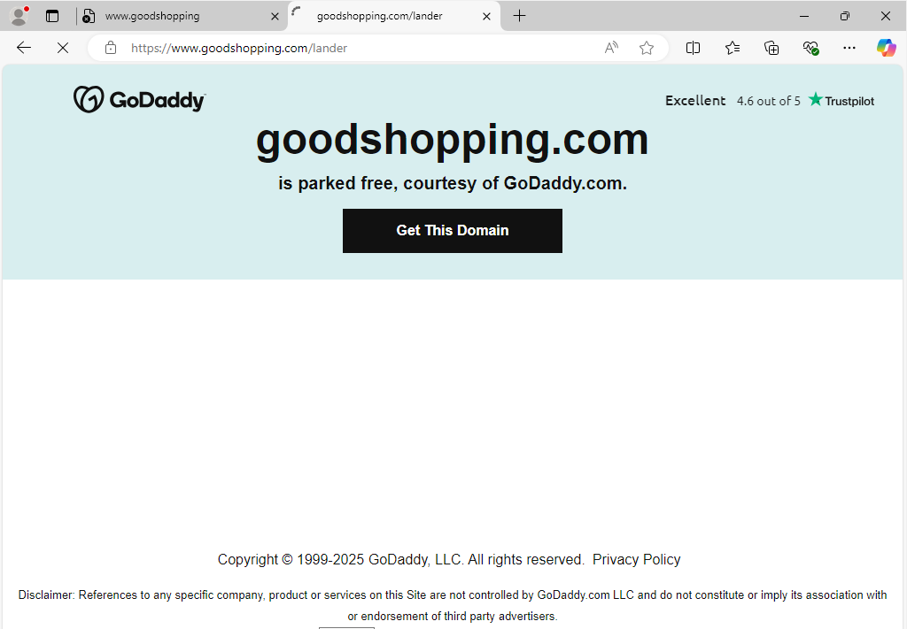

****LAB 3 AND LAB 4 – EMAIL AND DISK ENCRYPTION****

## ****Objective of the Module****

This module introduced us to practical data protection methods using disk and email encryption techniques. We explored how disk encryption secures entire drives from unauthorized access and how email encryption ensures confidentiality and authenticity of communication. By applying GUI-based encryption tools, we learned their configurations, strengths, and potential vulnerabilities in real-world scenarios.

**Environment Setup**

| Component | Specification |
| --- | --- |
| Attacker / Host OS | Windows 11 Pro |
| Target / Lab OS | Windows Server 2019 |
| Virtualization Tool | Oracle VirtualBox |
| Network Type | Host-only Adapter |
| Dependencies | BitLocker, EFS (Windows), Gmail Client |

**Tools Used**

**Disk Encryption (Windows 11 VM)**

| Tool | Function |
| --- | --- |
| VeraCrypt | Create encrypted volumes or apply full disk encryption |
| BitLocker | Built-in Windows drive encryption with TPM/password support |
| Rohos Mini Drive | Encrypt USB drives and create hidden encrypted partitions |

**Email Encryption (Windows 11 & Windows Server 2019 VMs)**

| Tool | Usage | Platforms |
| --- | --- | --- |
| [RMail.com](https://www.rmail.com/) | Send encrypted and legally verifiable emails, get read receipts | Windows 11, Windows Server 2019 |

**Lab 03 : Email Encryption**

**Task 1 : RMail**

****Execution Steps**:**

In both the Windows 11 and Windows Server 2019 VMs, I used a web browser to access [RMail.com](https://www.rmail.com/), an email encryption service. I logged into my Gmail account and used RMail’s secure message center to compose an email.

**Steps followed:**

* I wrote a test message and attached a dummy file (e.g., TestDoc.pdf).
* Before sending, I selected **Encrypt**, **Registered Receipt**, and **E-Signature** options from the RMail toolbar in the interface.
* I sent the email to myself to verify if the encryption and delivery tracking worked.
* Upon receiving the email, I was able to:
  + Verify the **digital signature** confirming sender authenticity.
  + Download the attachment securely (password-protected).
  + Review the **Registered Receipt™**, which confirmed delivery, open time, and IP location for compliance purposes.

This demonstrated secure end-to-end communication, message integrity, and traceability through GUI alone.

Screenshots: IDENTIFIER ==> clearly visible desktop with personal and lab related files. You can see the name of my device from the file paths.

-- Using Rmail to make an account linked to my gmail from windows 11 vm--

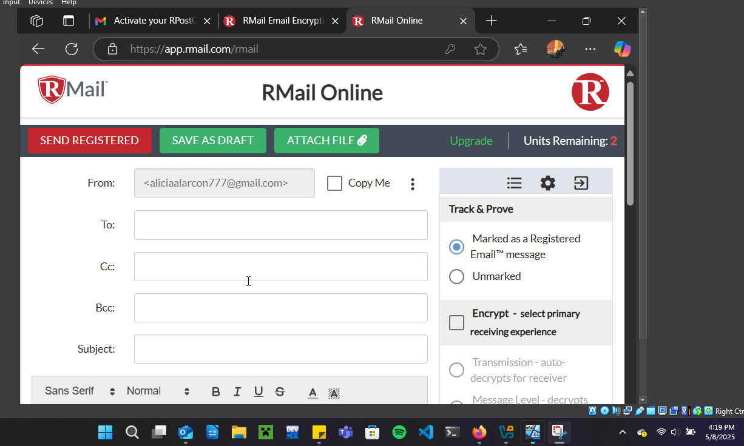

-- Sent a test email and got confirmation that it got send--

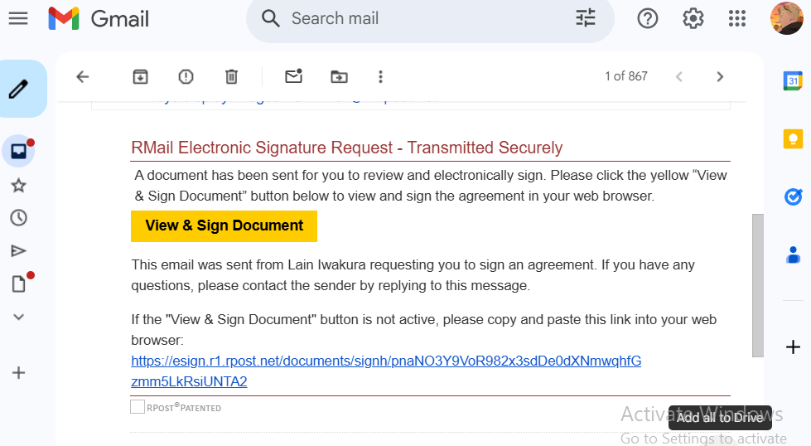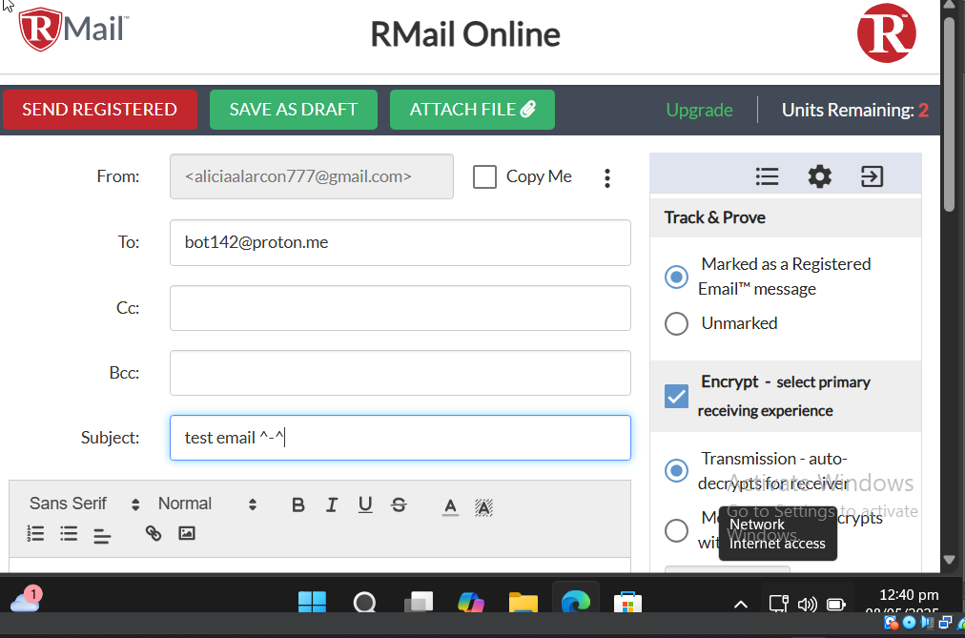

--Viewing the email from the windows 2019 server vm:--

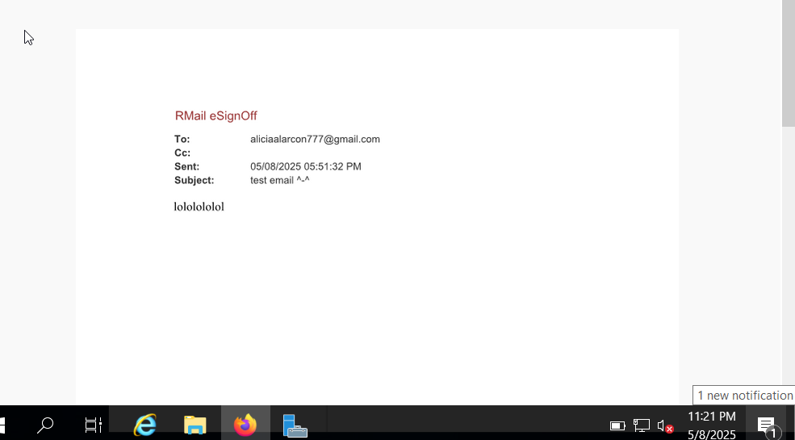

--Adding an electronic signature (from windows server 2019--

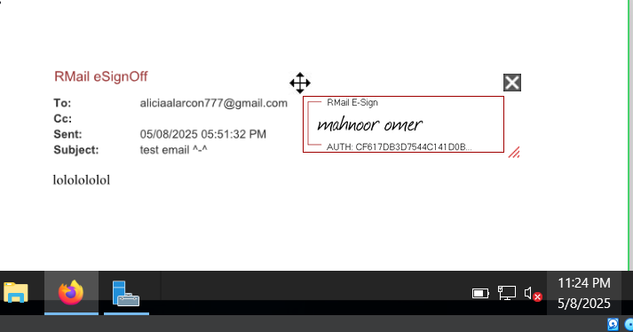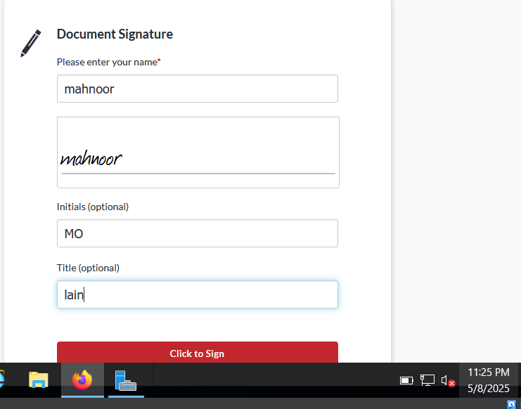

--Confirmation for electronic signature--

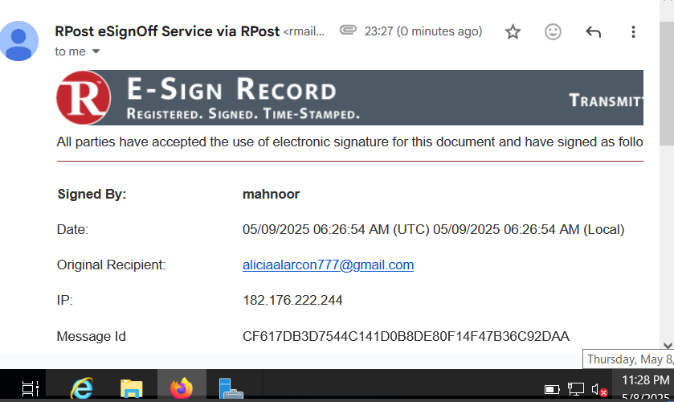

--Proof of transfer email from Rmail with all the details (from the windows 11 server--

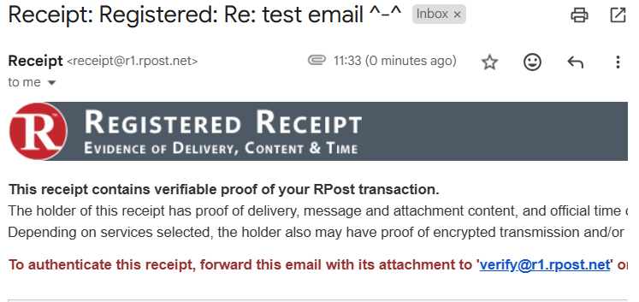

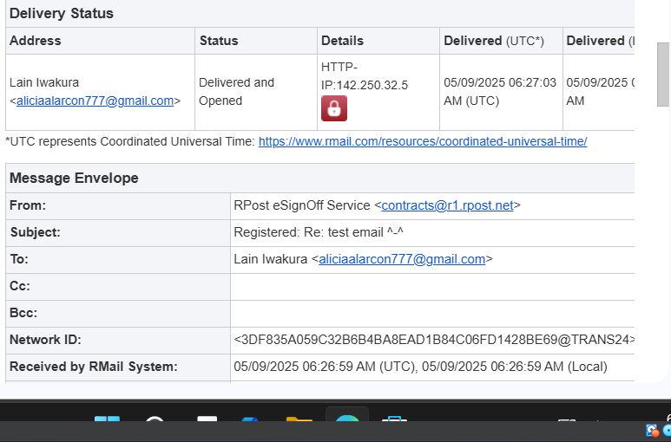

**Lab 04 : Disk Encryption**

**Task 1: Veracrypt**

****Usage Summary**:**

Create an encrypted virtual disk volume using the GUI and mount it as a secure drive.

**Steps followed:**

* Opened VeraCrypt and clicked **"Create Volume"**.
* Chose **"Create an encrypted file container"** and selected **Standard VeraCrypt volume**.
* Named the volume (e.g., EncryptedSafe.hc) and specified the location to save the container.
* Chose **AES encryption** and set volume size (e.g., 100 MB).
* Set a strong password for encryption.
* Chose the filesystem type (**NTFS**) and formatted the volume.
* After creation, I clicked **Select File**, mounted the container on a drive letter (e.g., Z:), and entered the password.
* Once mounted, it appeared as a normal drive in File Explorer.
* I created a test file secret_note.txt inside the encrypted volume and saved dummy content.
* Then I dismounted the drive to secure the content.

This showed how encrypted volumes could be created, mounted, and used like regular drives—all through the GUI.

Screenshots: IDENTIFIER ==> clearly visible desktop with personal and lab related files. You can see the name of my device from the file paths.

--setting up my new volume named myvolume on desktop--

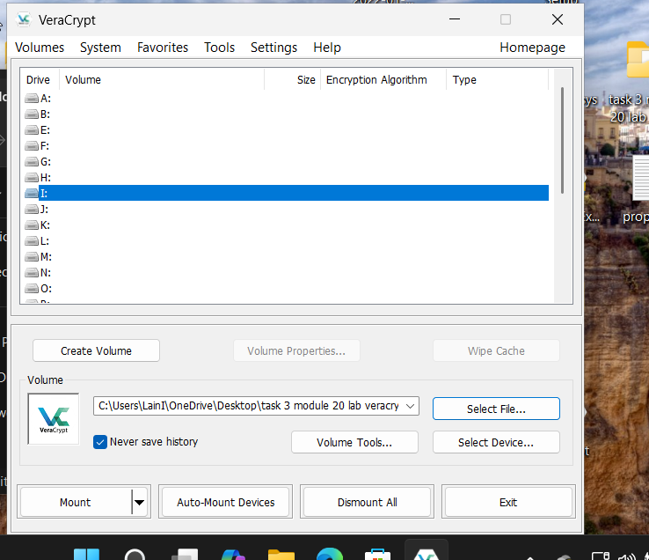

--creating my encrypted volume--

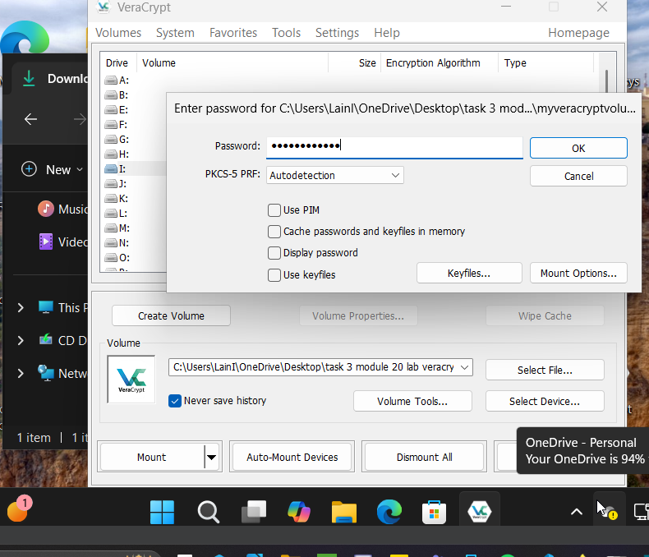

**--select test document to mount in drive--**

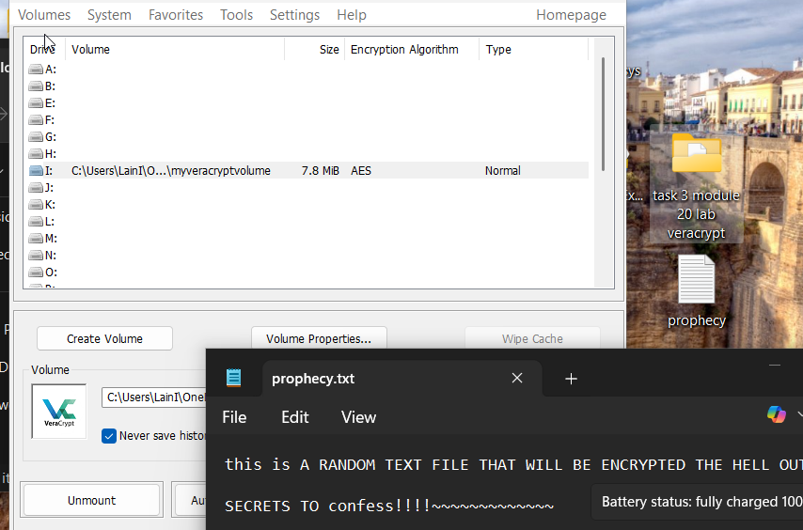

-- file has been successfully mounted on drive and requires a password to access--

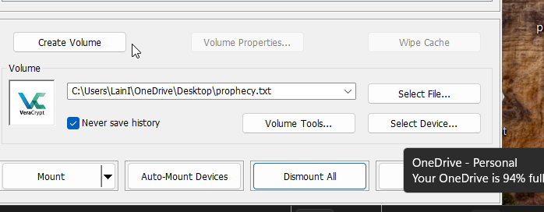**--**

**TASK 2 : BitLocker Disk Encryption**

**Usage Summary**:

Encrypt an internal drive using Windows' built-in GUI tool with password protection.

**Steps followed:**

* Opened **Control Panel > System and Security > BitLocker Drive Encryption**.
* Selected the secondary disk (D:) and clicked **"Turn on BitLocker"**.
* Chose **"Use a password to unlock the drive"**, and entered a secure password.
* Chose to save the recovery key to my USB for backup.
* Selected **Encrypt entire drive** and used the **Compatible mode** option.
* BitLocker then encrypted the drive in the background via the GUI.
* Once completed, I locked the drive and tested unlocking it with the password.
* I created a sample file confidential.docx inside the drive to verify normal functionality.

This proved how full-drive encryption can be implemented with minimal effort using native Windows GUI tools.

Screenshots: IDENTIFIER ==> clearly visible desktop with personal and lab related files. You can see the name of my device from the file paths.

-- Partition a new disk as new volume E to use in Bitlocker and making it password protected--

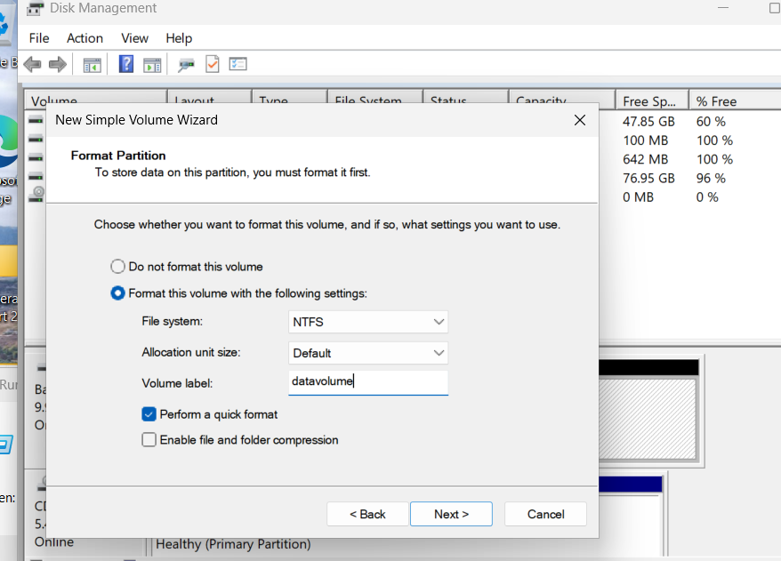

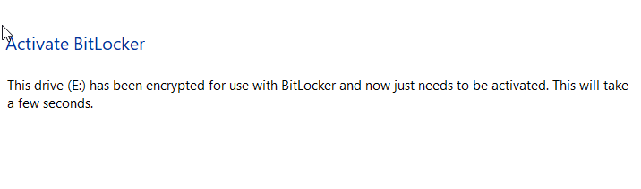

-- Disk E has been successfully encrypted and is protected with a password to access--

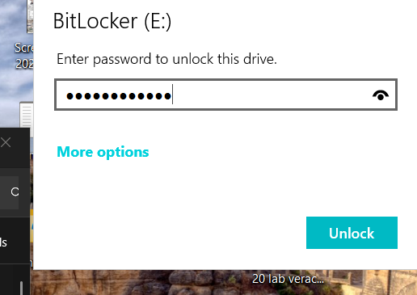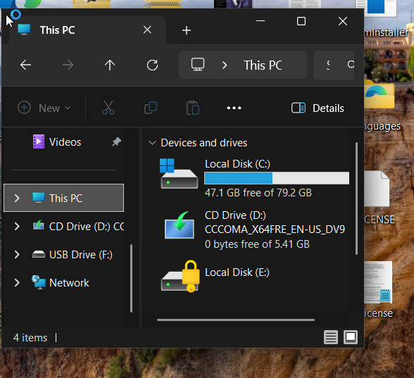

**TASK 3 : Rohos Drive Encryption**

**Usage Summary:**

Create a secure, encrypted virtual drive on your system or USB device using a password-protected container.

**Steps Followed in GUI:**

* Opened **Rohos Drive Encryption** from the Start menu after installation.
* In the GUI, clicked **Encrypt USB drive** or **Create a new encrypted drive**
* Selected the storage location for the encrypted container file (on D:\ or internal drive).
* Set a drive size (10 MB) and a **strong password** to protect access to the container.
* Chose encryption options like **AES-256** and confirmed the settings.
* Rohos then created a secure, hidden volume file that appears as a normal drive when mounted.
* I launched the **Rohos Disk Browser** by selecting o**pen drive** from the main interface and entered the password to mount the drive.
* Inside the mounted encrypted drive, I created a **test document** called testdoc.txt and typed sample content.
* After testing access, I **unmounted the encrypted drive** using the GUI.
* The encrypted container was no longer visible or accessible without Rohos and the correct password.

This process demonstrated how Rohos can be used to create **password-protected encrypted drives** using an intuitive GUI, suitable for securely storing confidential files without command-line use.

Screenshots: IDENTIFIER ==> clearly visible desktop with personal and lab related files. You can see the name of my device from the file paths.

-- Opening up Rohos and creating a new disk volume to encrypt--

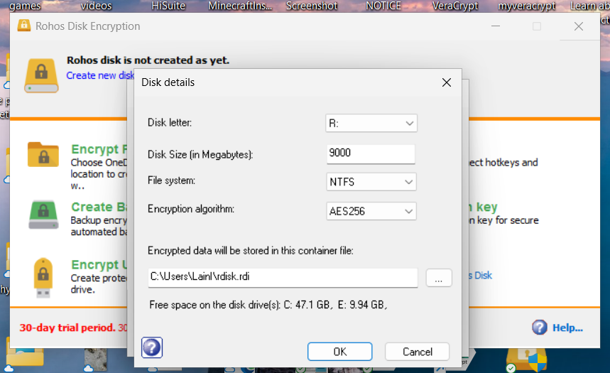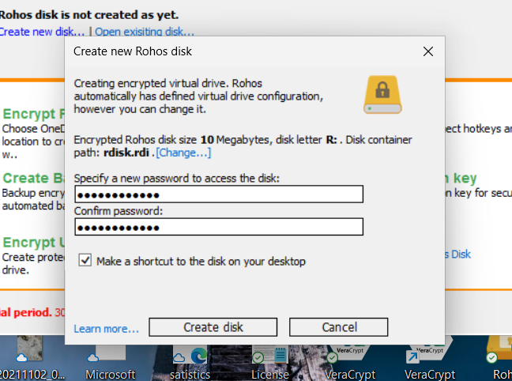

-- Test document created and stored in encrypted disk--

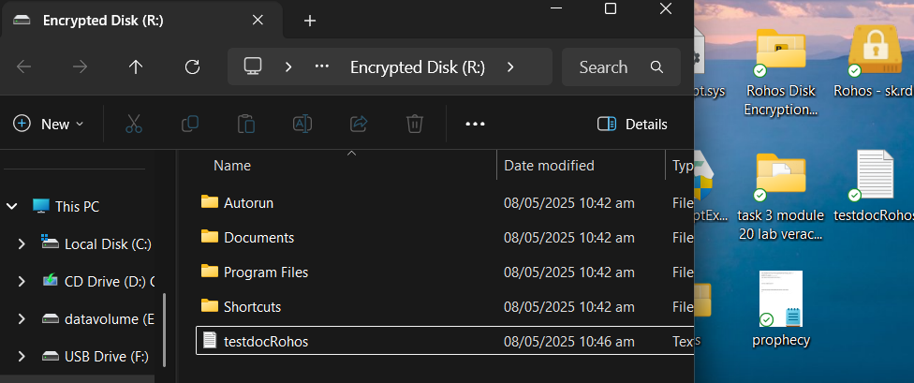

--Closed the disk and tired to access it again. The disk now is now storing the file and only users with password can access.--

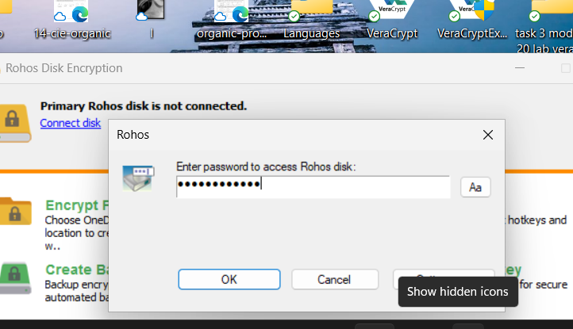

## ****Errors Faced & How They Were Solved****

No errors were encountered during these lab tasks. All GUI-based tools and procedures functioned as expected on both Windows 11 and Windows Server 2019 environments.

## ****Final Learning and Reflection****

Through this module, I gained practical knowledge of disk and email encryption mechanisms on Windows systems. I now understand how BitLocker and EFS function differently, and how to apply encryption using Outlook for secure communication. I also learned the real-world applications of these tools and how they contribute to data security. The process highlighted how even built-in OS features can enforce strong protection without complex command-line tools. This reinforced my understanding of confidentiality, access control, and the importance of key management in cybersecurity.

**LAB 5 Cryptography**

**LAB 1 Honeypots**

**Lab objectives:**

* Performed cryptoanalysis using the crypTool.
* Performed cryptoanalysis using the AlphaPeelar.

**Lab environment:**

* Window 11 virtual machine.
* Window server 2019/2022.
* Internet connection.
* Administrator’s privileges.

**Tool used:**

1. CrypTool
2. AlphaTool

**Lab tasks**

In this lab we must perform the two task one using the cryTool and other using the AlphaPeeler

**Task#1**

**Performed cryptoanalysis using the crypTool.**

CrypTool is an open-source e-learning application that helps users understand cryptographic and cryptanalytic concepts through hands-on experience.

In this task we only needed the window 11 virtual machine.

* First, we need to see if we have crytool installed, if yes, well and good, if not then install. In our case we had to install the crytool.
* Now open the window search bar search for the crytool.

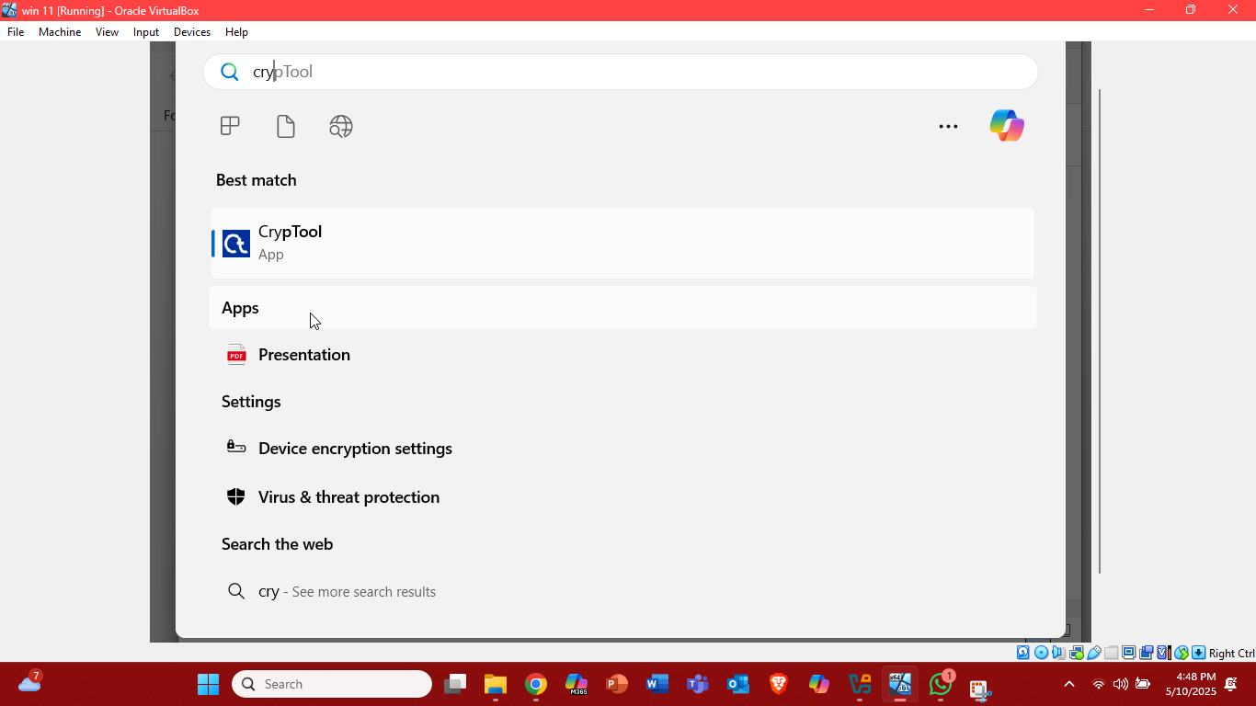

* Now the crytool is open, a multicolor screen will popup there at the bottom click on don’t show again.

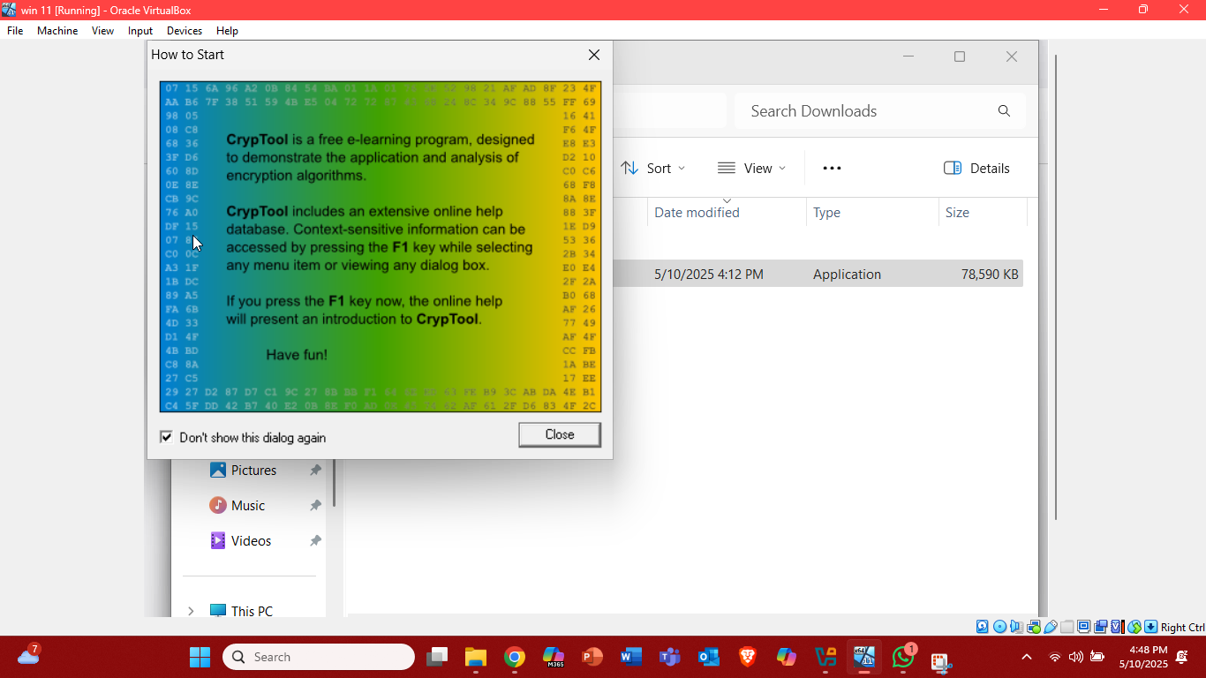

* Now at the top left click on the file and make the new file which we are going to encrypt.

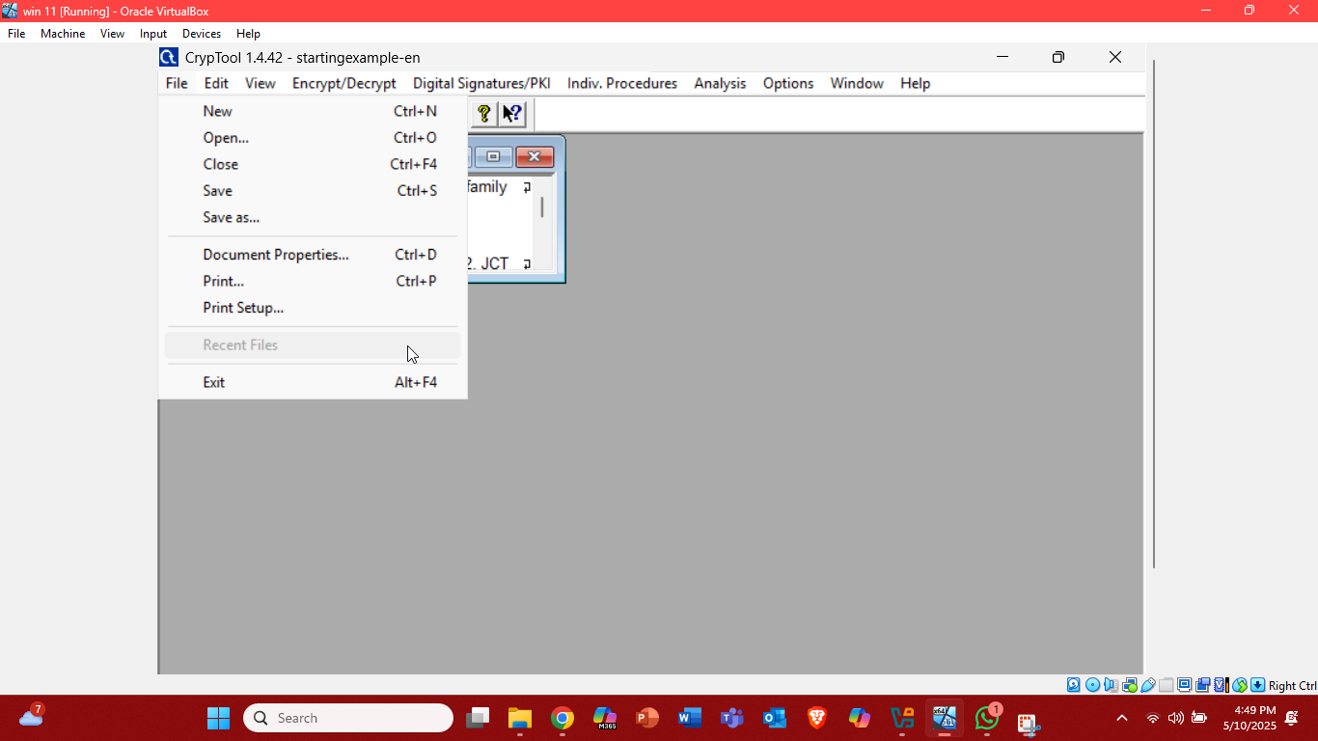

* We must chose the algorithm to encrypt our file which we created.

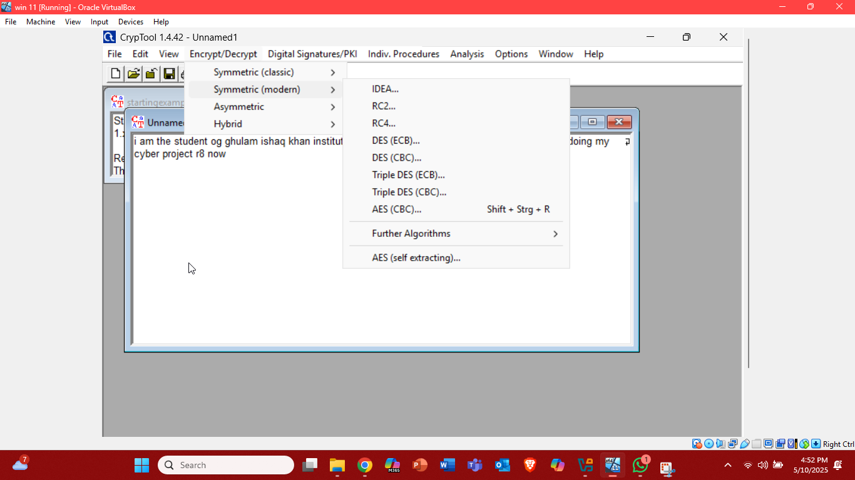

At the top click on the encrypt/decrypt you will see the types of cryptography symmetric, asymmetric and hybrid. Click on the symmetric(modern) and then RC2.

* Now enter the key length in hexadecimal. In my case I selected the 06. And then click on encrypt.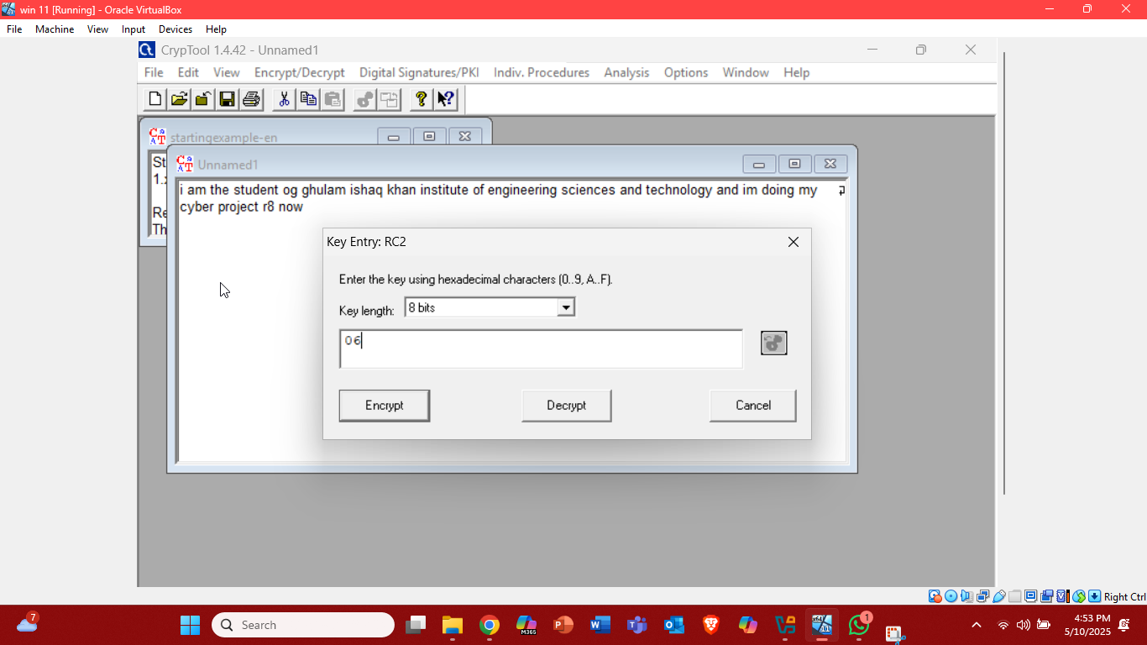
* Now it shows our crypted text.

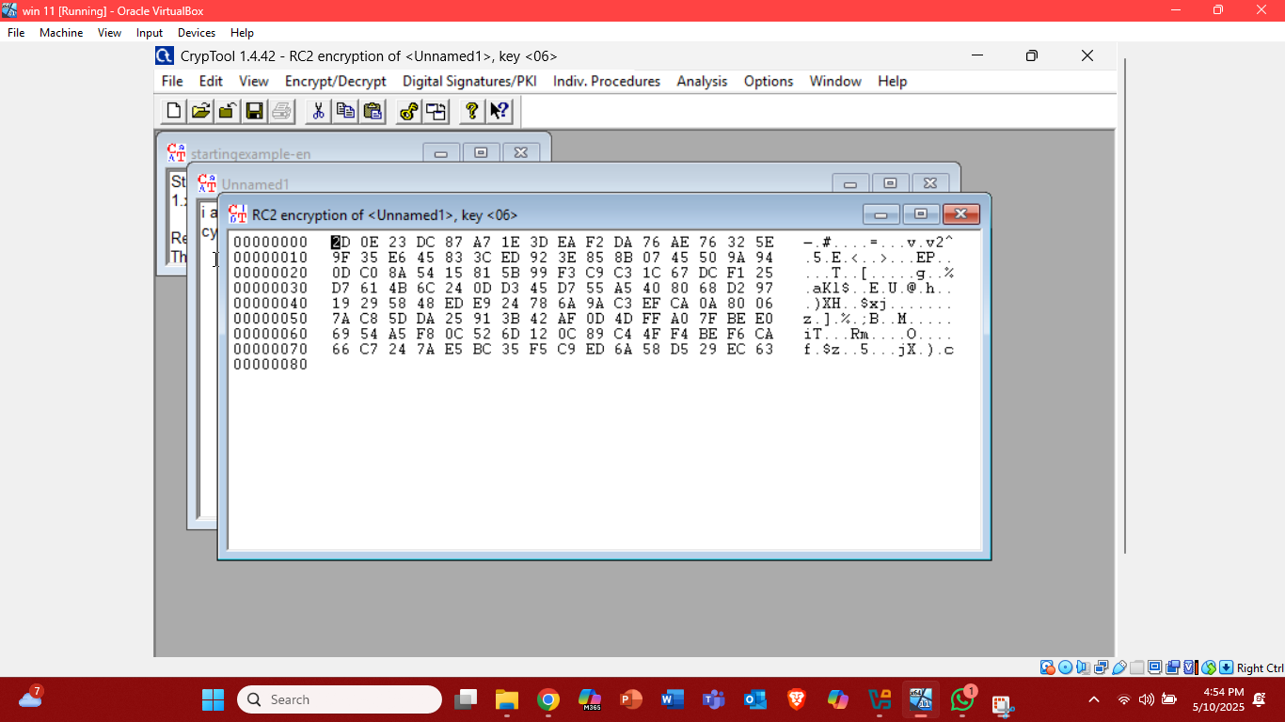

* Save that file.

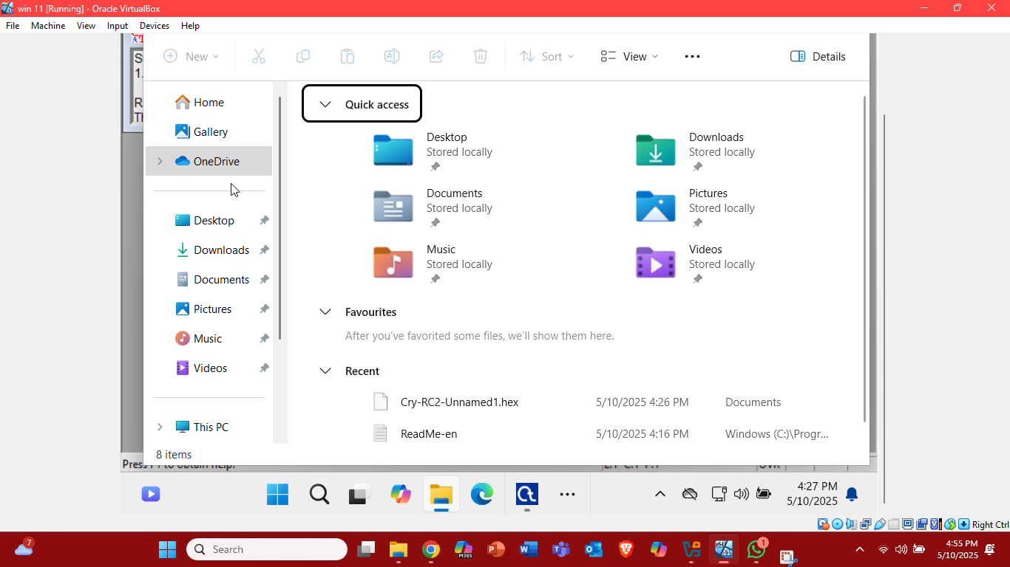

Yyyaayy done with task#1.

**Task# 2**

**Performed cryptoanalysis using the AlphaPeelar**

AlphaPeelar is a simple educational tool used for understanding and practicing classicalencryption and decryption techniques. It is mainly used in academic settings (like cybersecurity labs or courses) to demonstrate how traditional ciphers work.

In this lab we need windows 11 virtual machine and the windows server 2022/2019 virtual machine.

* First open the window 11 virtual machine. Now see if we have AlphaPeeler installed, if yes, well and good, if not install. In our case we had to install the AlphaPeeler.
* Now in the search bar search bar open the AlphaPeelar. 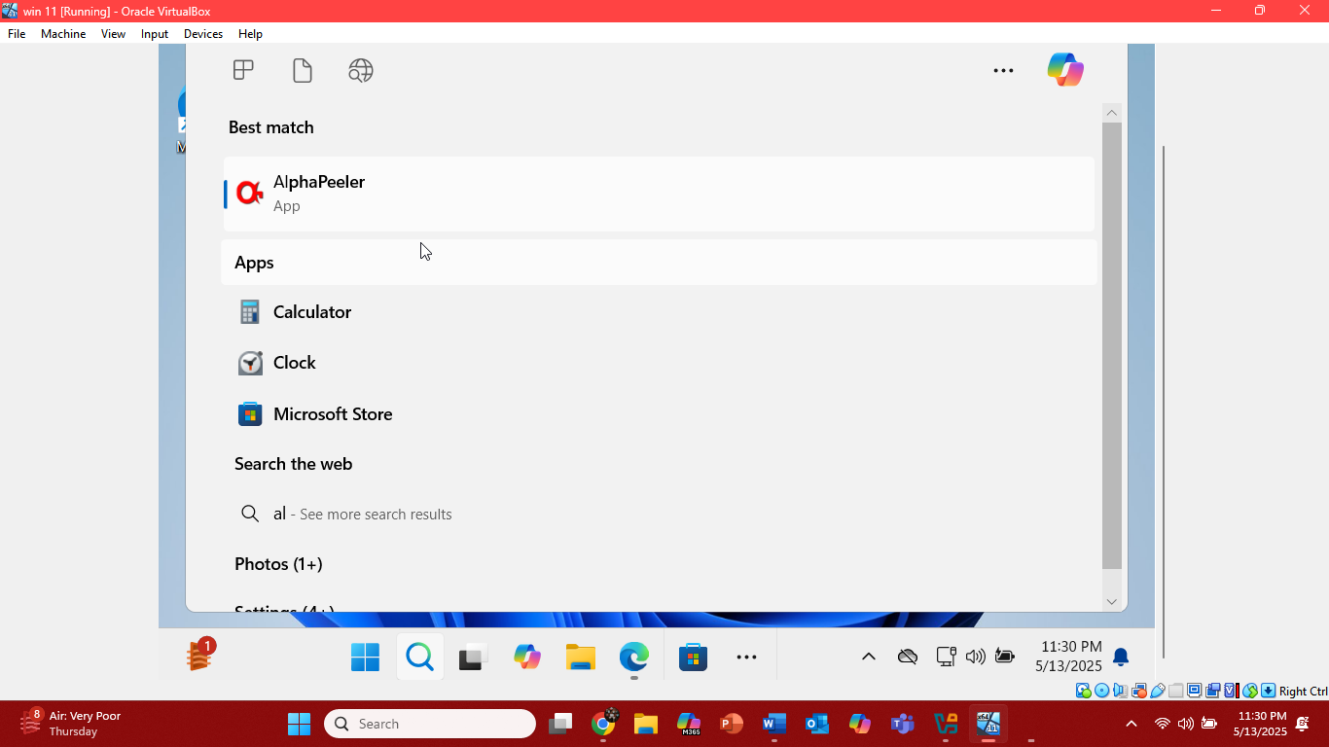
* Now the AlphaPeeler is open. 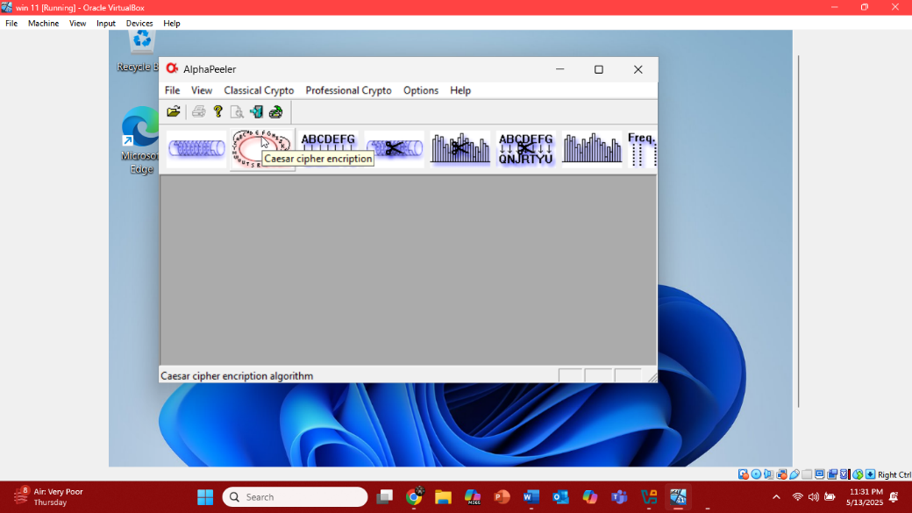
* Minimize the AlphaPeelar and make the .txt file at the desktop which includes the text you want to encrypt.

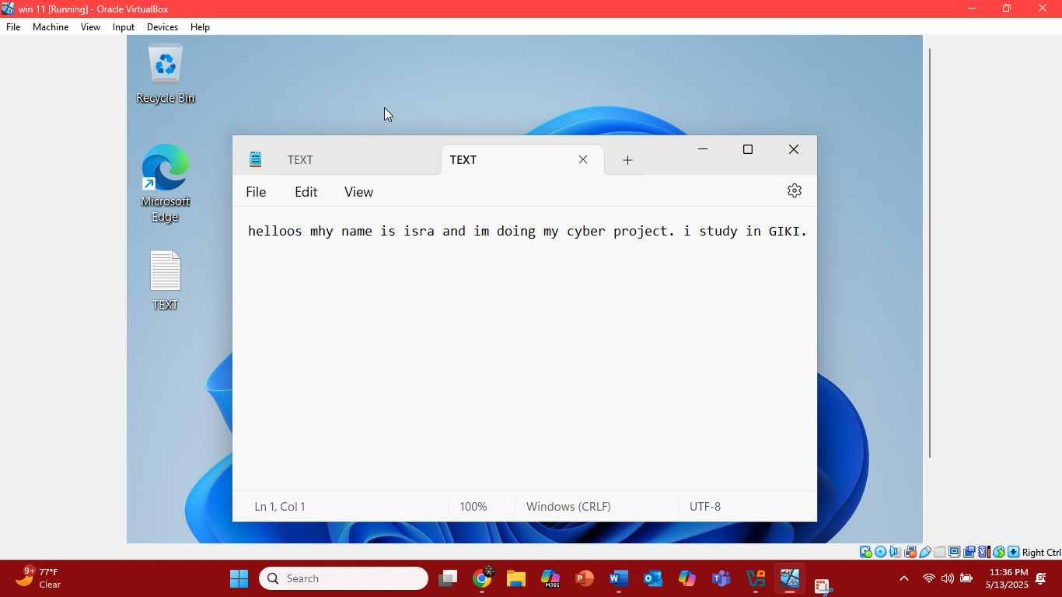

* Now the AlphaPeeler opens again. Click at the professional crypto at the top of the tool and select the DES to perform this cryptography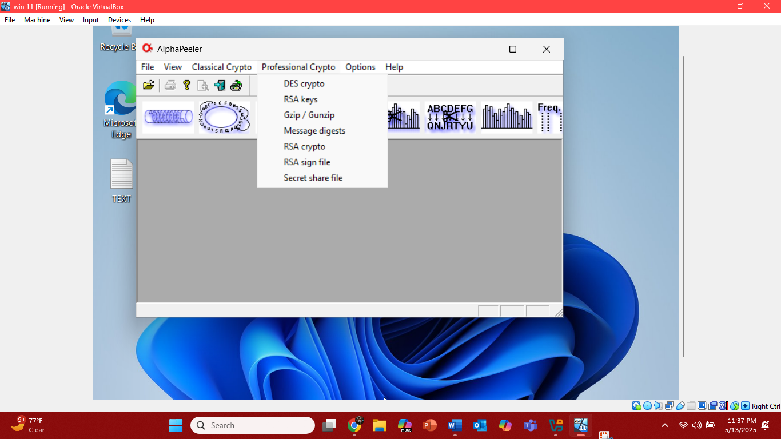
* After selecting the algorithm an encryption decryption box will pop up add the file which you created before in the plain text file and make a new file in cipher text box so that encrypted text will be add in that file, then add the password in the last block pass phase. 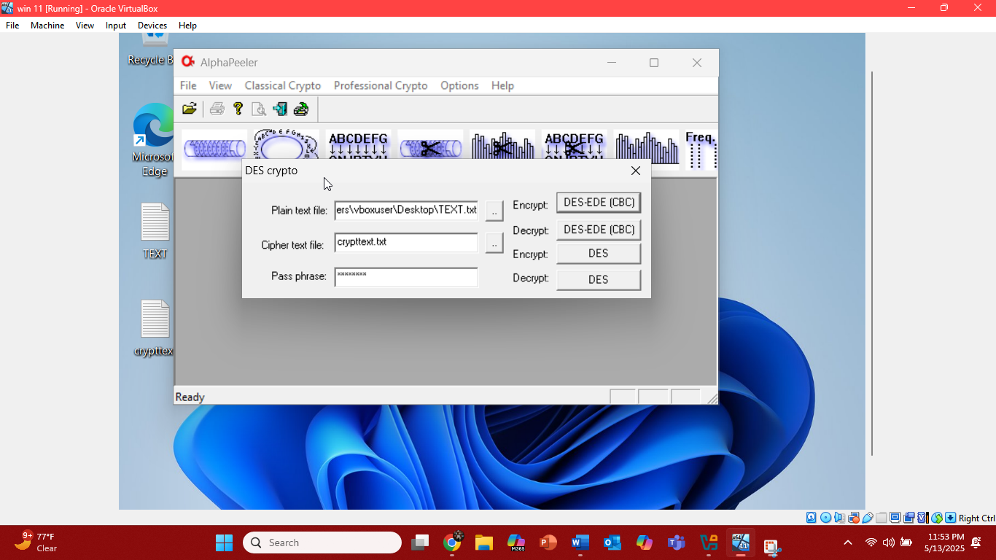

And click on the DES_EDE(CBC) where encrypt is written.

* Then that cipher text file will be saved open it and see the cipher text. 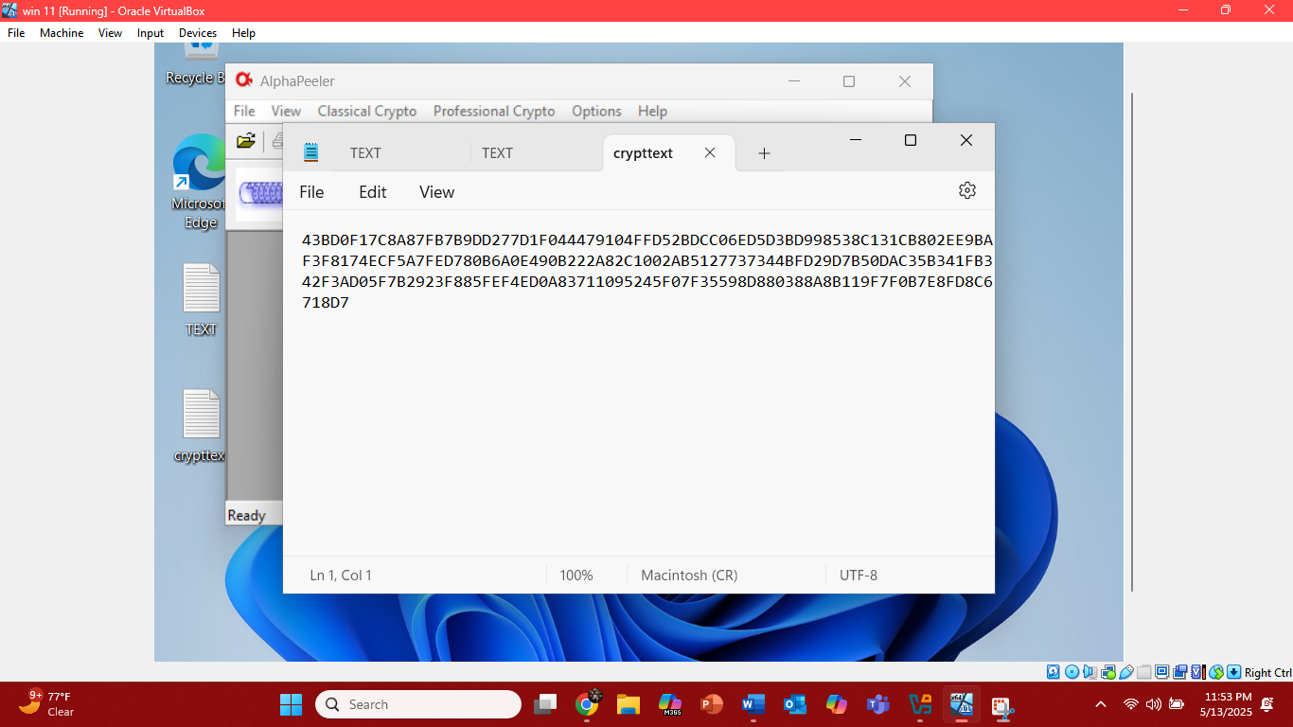
* Now open your window server 2022/2019 here follow the same step as before search or the same tool open it now first here encrypt the text and then save the cipher text file then delete the original text, just for practice to show how we can convert the cipher text back into original text using the AlphaPeeler. Here now at the after clicking on the professional crypt select the DES. Now add the cipher text file to the cipher text file block and make the file for the result in plain text file box and then pass the key to decrypt it.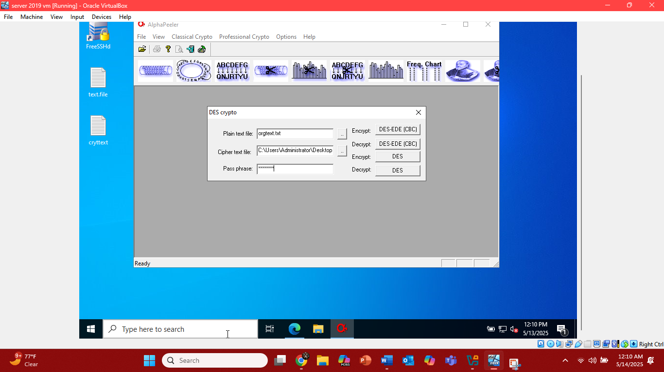
* Now you can see the original text.

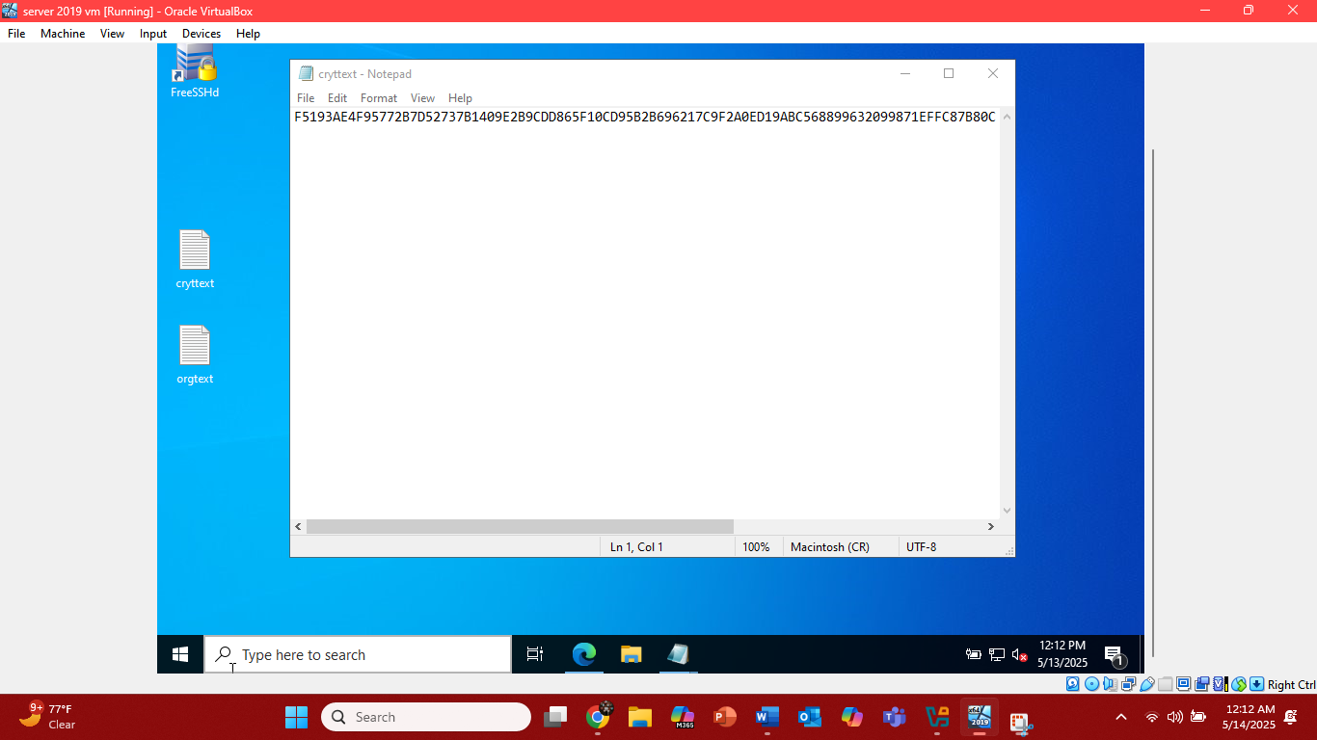

Yaaaaayyyyy done with task two as well.

**Lab# 1**

**Perform intrusion detection using various tools**

**Lab objective:**

Detect malicious network traffic using HoneyBOT.

**Lab environment:**

1. Window 11 virtual machine.
2. Window server 2019/2022.
3. Parrot OS virtual machine.
4. Internet connection.
5. Administrator’s privileges.

**Lab task:**

In this lab we are going to detect the malicious traffic using honeyBOT.

**Task# 3**

**Intrusion detection using honeyBOT**

HoneyBOT is a medium-interaction honeypot for Windows systems. It operates by opening over 1,000 TCP and UDP ports that mimic vulnerable services, enticing attackers to interact. These interactions are logged in detail, capturing raw packet data, including keystrokes and attempted exploits. The tool can safely store any uploaded malware, such as trojans or rootkits, for further analysis. It's primarily used to monitor and study malicious traffic, aiding in the development of defensive strategies.

Open your window server 2019/2022 virtual machine.

1. First, we need to see if we have HoneyBOT installed, if yes, well and good, if not then install. In our case we had to install the HoneyBOT.
2. Now open the file explorer and search for the honeyBOT extension and start the wizard installation setup.

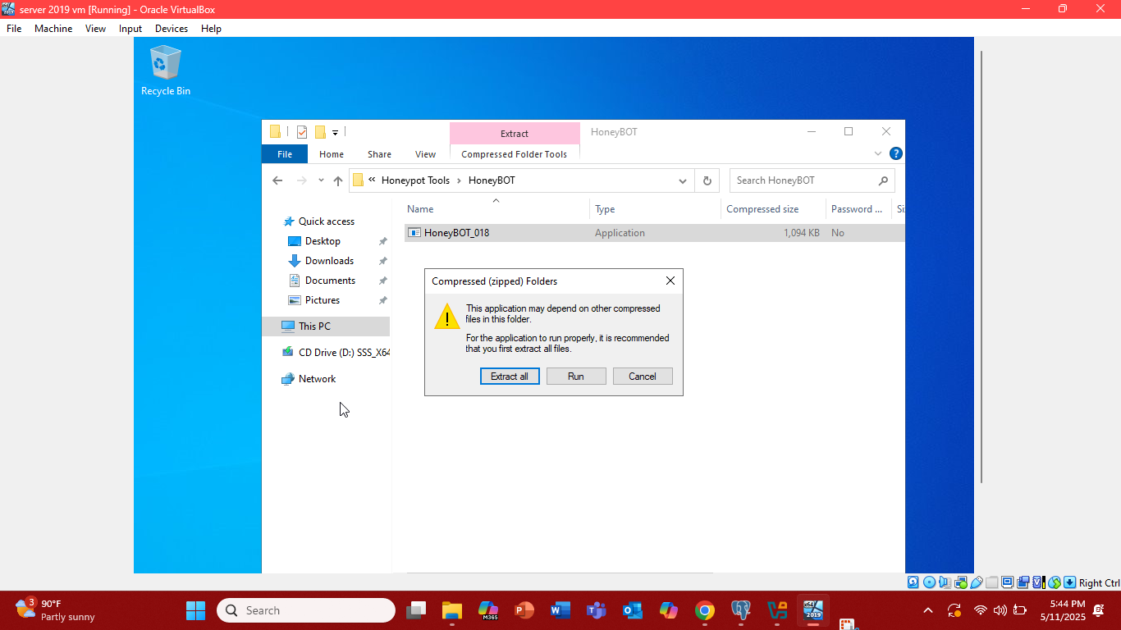

1. Now open the search for the honeyBOT on search bar and open it. A popup will appear asking to configure the honeyBOT click yes. Here we are leaving the setting on default for the general tab in option. 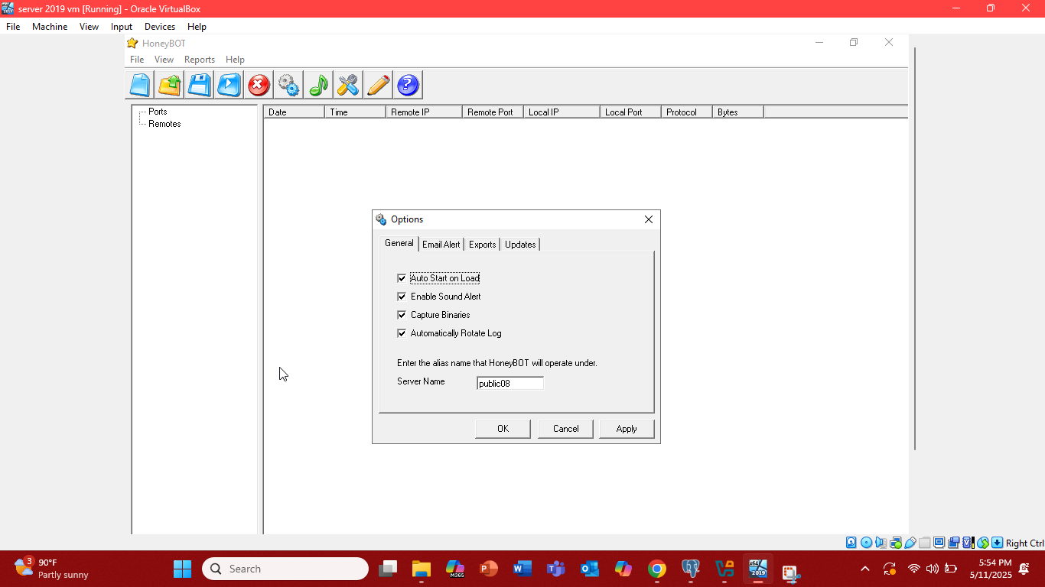
2. In the email alert, if you want HoneyBOT to send you emails click the send emails(in this lab we will not be dealing with this).

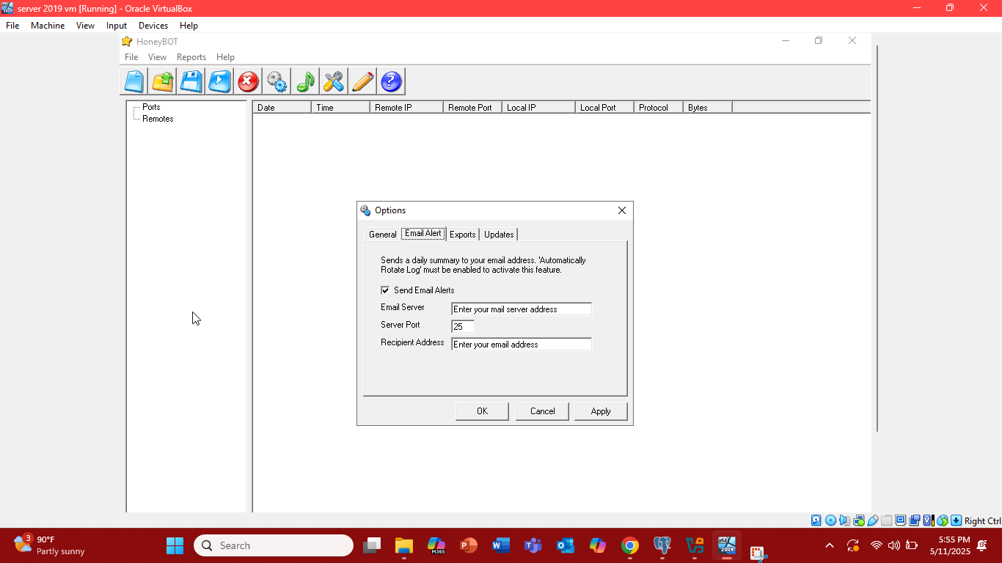

1. On the export tab, in which we can export the logs recorded by the HoneyBOT, choose the require button to see the required report. 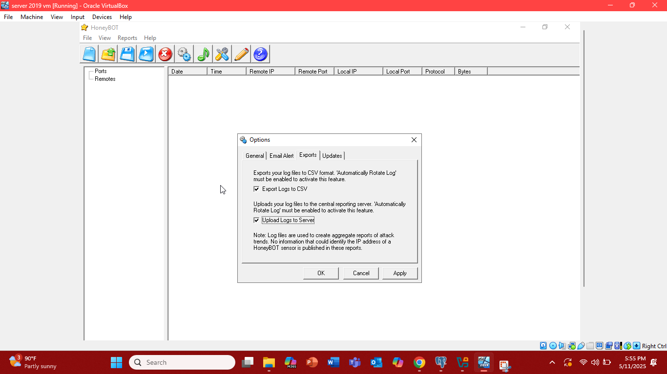click apply.
2. Let’s move to HoneyBOT on its main page, at the left side we can see the port and remotes, ports which ports are being used, and remotes are which IP is sending the malicious traffic.

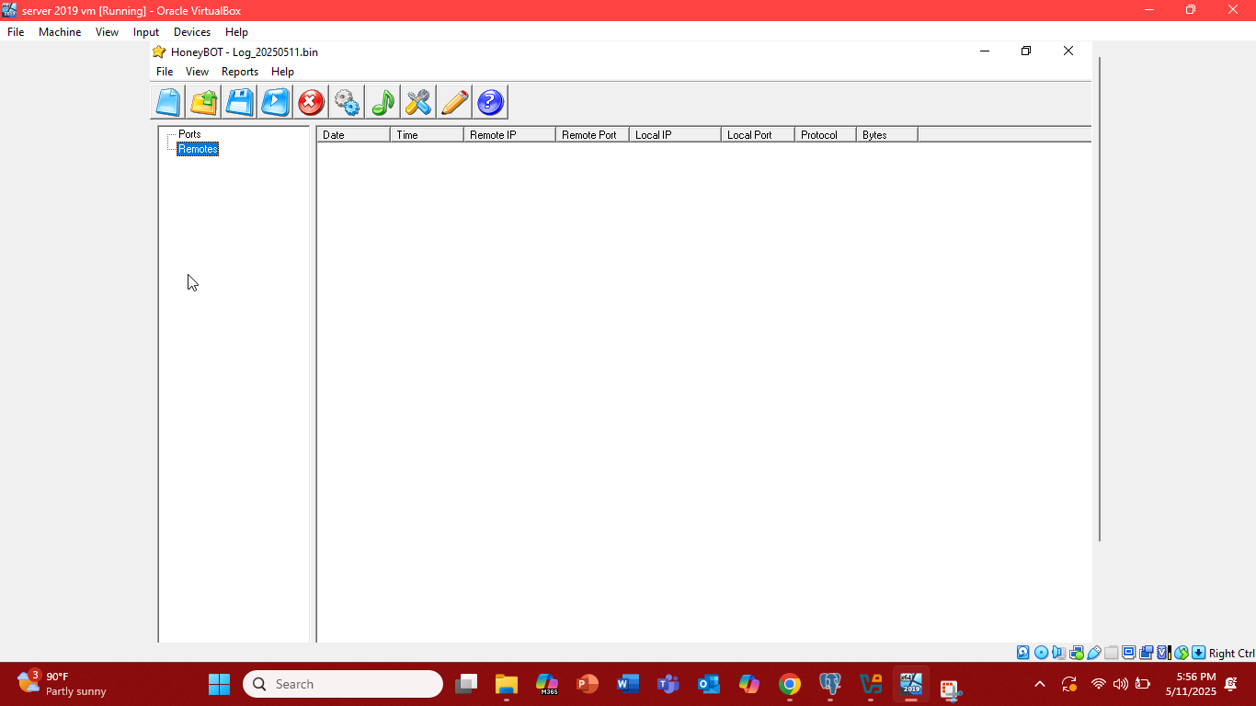

1. Now we have to send the traffic to this server 2019/2022 virtual machine from our parrot OS virtual machine. Switch to the parrot virtual machine. Keep the server virtual machine running.

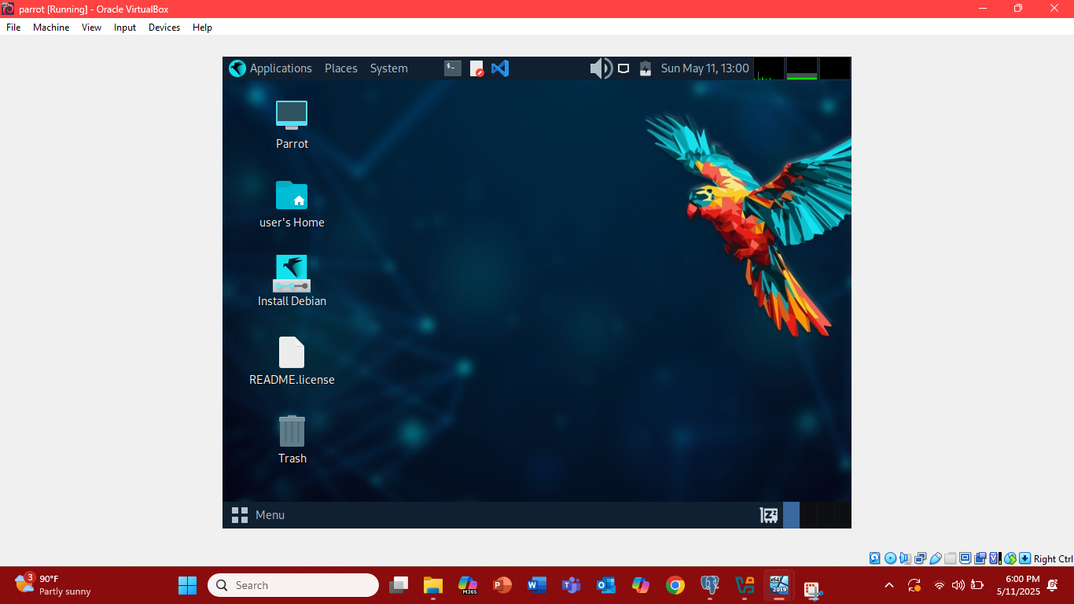

1. In parrot virtual machine opens the mate terminal of the parrot machine first type the **sudo su** in that terminal.
2. If you have a password set type password, click enter. Then type **cd** in mate terminal.
3. Then on the terminal window, now type the **telnet<host_ip>** this will send the connection request and then if connected malicious traffic will be noticed on the honeyBOT on server VM 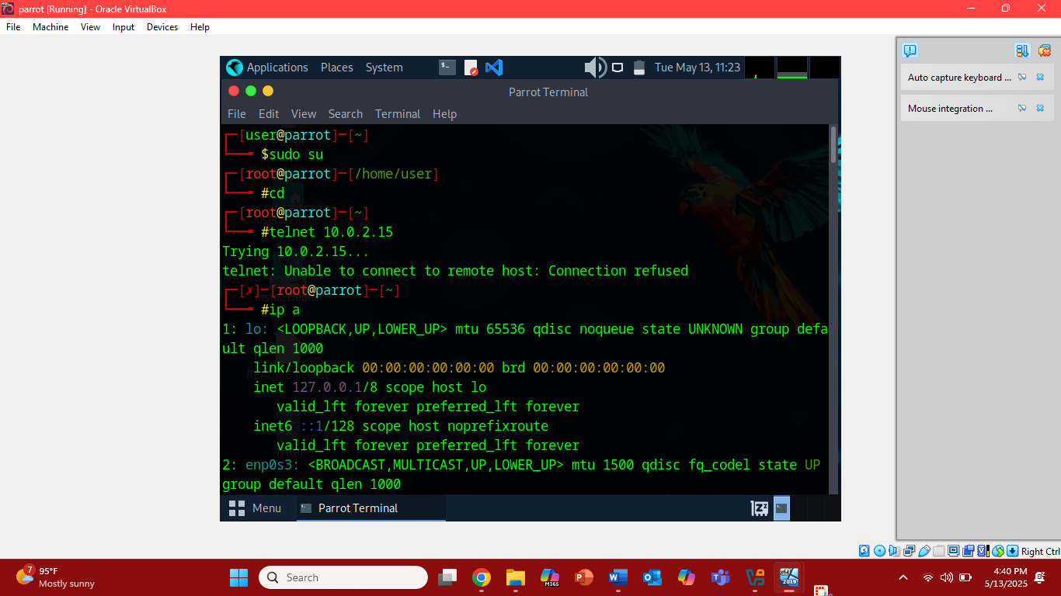

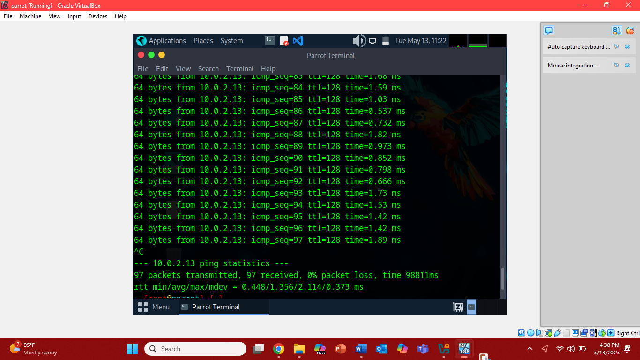

1. Now lets move to our server virtual machine and on the HoneyBOT we can see the the traffic

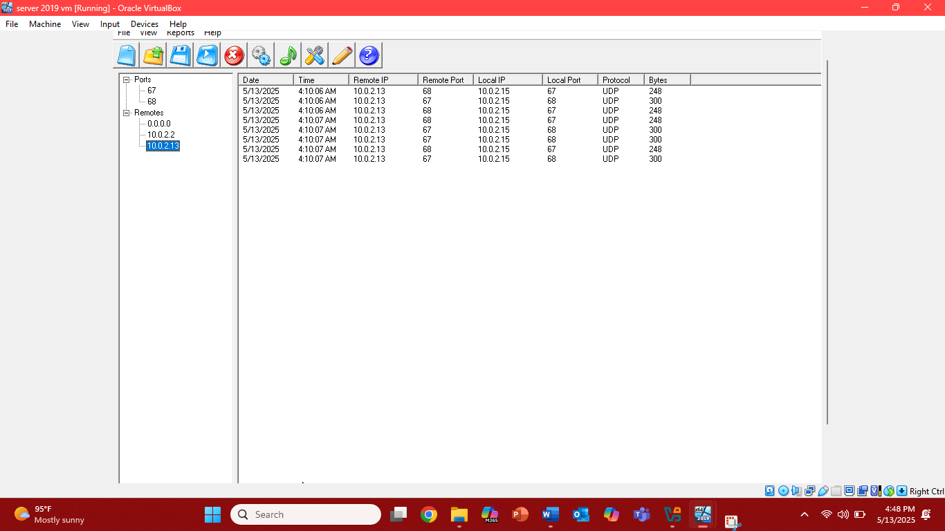

1. Select one of them at the right side of the dashboard and right click select the details and details will be shown at the left side of the screen.

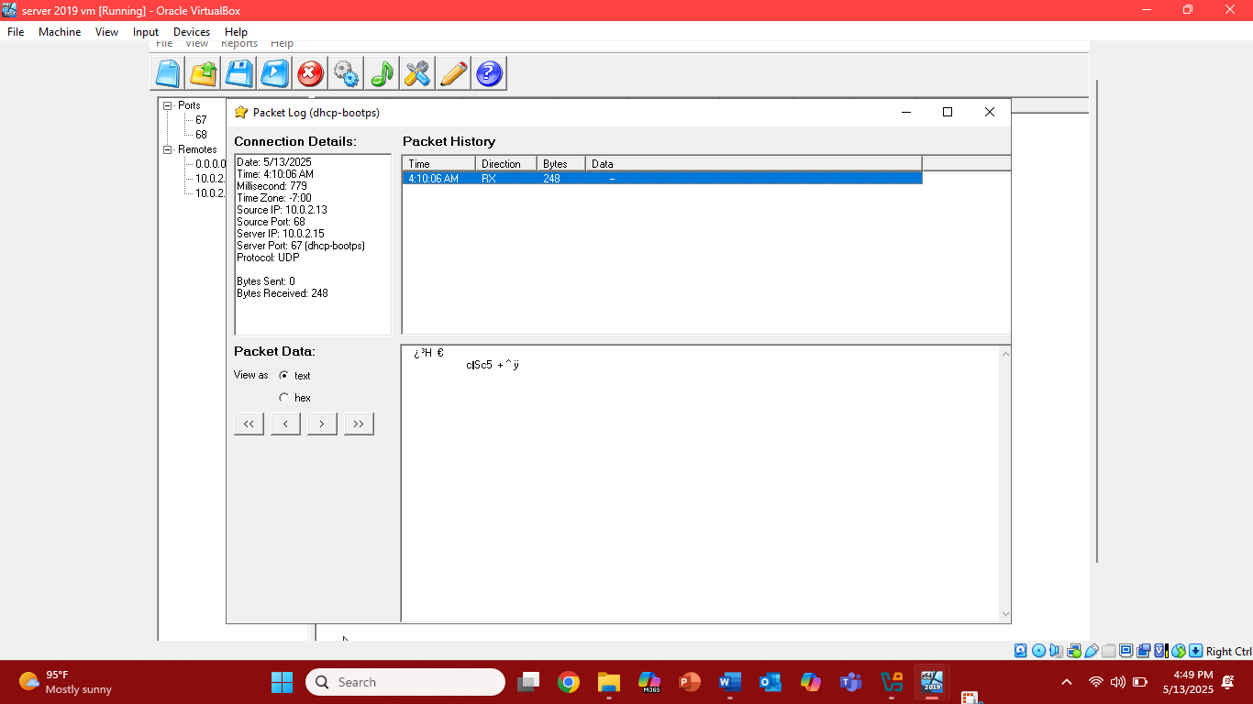

**Problem faced**

Didn’t face any problem in crypto labs except the internet solved it through the machine setting.

In HoneyBOT lab first it refused the connection between two VM for that I had to-do multiple things

1. Checked for the telnet server. Wasn’t there so had to install the freesshd server which serves as the telnet server still the same issue.
2. Then I had to check if the port is listening or not opened command prompt (win+r type cmd) then type netstat -aon | find listen.
3. After this port was listening then I had to figure out what can be the issue. There can be a firewall restriction. Checking for the port if firewall is applied. For this go to the window firewall defenderadvanced settinginbound rulenewruleportallow.
4. Now there shouldn’t be any problem, but still the same problem connection refused. Turn off the firewall.
5. Still the problem checked for the server if it is running or not. It was working as well.
6. Faced the same issue, it turned out the IP was getting on the server was of 169. Then I looked for DHCP server. There was no DHCP server installed through the server manager.
7. Statically assigned IP to the machine then connection was easily established.
8. Took so long to figure out the problem.